**Introduction**

In response to significant losses experienced by clients in 2022 within their income-oriented asset allocation strategies, particularly in conservative portfolios represented by the Vanguard LifeStrategy Income Fund (VASIX), our asset management firm seeks to explore alternative portfolio strategies. Many clients shifted their investments to Treasury Bills when interest rates surpassed 4.0%, finding solace in these seemingly safer options. However, with the Federal Reserve beginning to lower interest rates, clients are looking for new strategies that offer returns exceeding 4.0%, without the substantial drawdowns they encountered in 2022.

In this report, we aim to investigate a variety of liquid investment funds, spanning a spectrum of correlation profiles. By combining these diverse assets, we believe that we can meet the needs of our clients, offering better risk-adjusted returns. We leverage portfolio optimization techniques, motivated by Clarke, de Silva, and Thorley (2013), to evaluate Risk Parity, Minimum Variance, and Maximum Diversification approaches. Our analysis concludes that a Risk Parity allocation offers the most balanced risk-return profile, avoiding the exclusion of any particular asset class, and better aligns with the evolving needs of our clients.

**Data Cleaning/Preparation**

For this analysis, we gathered monthly total return data for 15 mutual funds and exchange-traded funds (ETFs) from Yahoo Finance. The dataset covers the period from November 2014 through August 2024. Vanguard LifeStrategy Income Fund (VASIX) serves as the benchmark for this study, and the following assets form the opportunity set:

* Vanguard Total World Stock ETF (VT)
* PIMCO 25+ Year Zero Coupon US Treasury ETF (ZROZ)
* AQR Diversified Arbitrage I (ADAIX)
* iShares Gold Trust (IAU)
* Bitcoin Market Price USD (^BTC)
* AQR Risk-Balanced Commodities Strategy I (ARCIX)
* AQR Long-Short Equity I (QLEIX)
* AQR Style Premia Alternative I (QSPIX)
* AQR Equity Market Neutral I (QMNIX)
* AQR Macro Opportunities I (QGMIX)
* AGF U.S. Market Neutral Anti-Beta (BTAL)
* AQR Managed Futures Strategy HV I (QMHIX)
* Invesco DB US Dollar Bullish (UUP)
* ProShares VIX Mid-Term Futures (VIXM)

The dataset was formatted with monthly returns in decimal form, with no missing data points. Because the data came from a single source (Yahoo Finance) in a standardized format, minimal preparation was required. However, in a more generalized scenario, we might have needed to handle issues such as missing data points, different data formats, and inconsistent timeframes. Additionally, we would have considered data smoothing techniques to account for outliers, particularly in highly volatile assets like Bitcoin. For our analysis, we opted to retain the raw data to better reflect real-world market conditions.

**Exploratory Data Analysis**

**Summary Statistics**

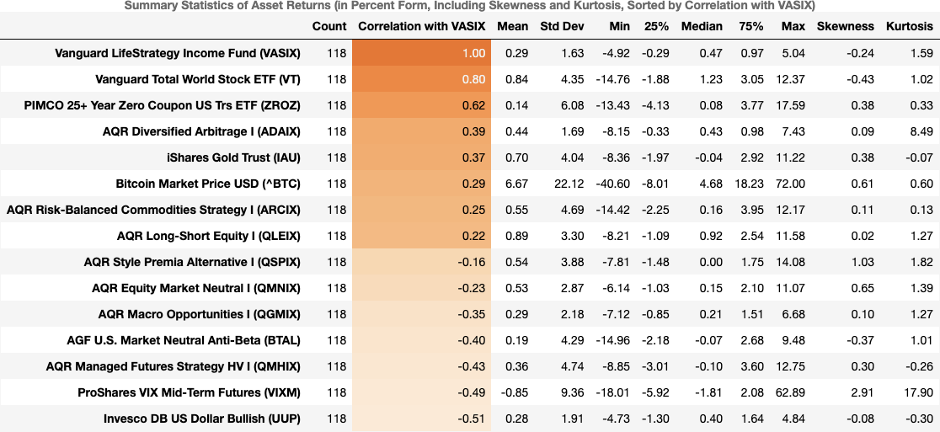

Here are bullet point observations based on the given summary statistics table:

Correlation with VASIX:

* Vanguard Total World Stock ETF (VT) has the highest positive correlation with VASIX (0.80), indicating a similar return behavior.
* PIMCO 25+ Year Zero Coupon US Trs ETF (ZROZ) also has a relatively strong correlation with VASIX (0.62).
* AGF U.S. Market Neutral Anti-Beta (BTAL) and Invesco DB US Dollar Bullish (UUP) have negative correlations with VASIX, suggesting they could provide effective diversification.

Risk Characteristics (Std Dev):

* Bitcoin (^BTC) has the highest standard deviation (22.12%), indicating the highest risk and volatility.
* AGF U.S. Market Neutral Anti-Beta (BTAL) and PIMCO 25+ Year Zero Coupon US Trs ETF (ZROZ) have relatively low standard deviations (4.29% and 6.08%, respectively), suggesting they may be less volatile.
* Vanguard LifeStrategy Income Fund (VASIX) itself has a low standard deviation (1.63%), reflecting its conservative nature.

Skewness and Kurtosis:

* Bitcoin (^BTC) and ProShares VIX Mid-Term Futures (VIXM) have high positive skewness, implying occasional extreme positive returns.
* AGF U.S. Market Neutral Anti-Beta (BTAL) and AQR Managed Futures Strategy HV I (QMHIX) exhibit negative skewness, suggesting a propensity for extreme negative returns.
* PIMCO 25+ Year Zero Coupon US Trs ETF (ZROZ) shows notable positive kurtosis, indicating the presence of extreme return events or outliers.

Return Distribution:

* Vanguard LifeStrategy Income Fund (VASIX) has a mean monthly return of 0.29%, reflecting stable performance with moderate risk.
* Bitcoin (^BTC) has the highest mean return (6.67%) but also the highest volatility, illustrating a risk-return trade-off.
* AGF U.S. Market Neutral Anti-Beta (BTAL) has one of the lowest mean returns (0.29%) with moderate skewness and high kurtosis, showing its defensive characteristics.

Min and Max Returns:

* Bitcoin (^BTC) has the widest range of returns, with a minimum of -40.60% and a maximum of 72.00%, underscoring its high risk profile.
* Vanguard LifeStrategy Income Fund (VASIX) and AGF U.S. Market Neutral Anti-Beta (BTAL) have narrow ranges, reflecting lower risk exposure and limited potential for extreme outcomes.

The correlation analysis reveals that Vanguard Total World Stock ETF (VT) and PIMCO 25+ Year Zero Coupon US Treasury ETF (ZROZ) share relatively strong relationships with Vanguard LifeStrategy Income Fund (VASIX), suggesting limited diversification benefits from adding these assets to a portfolio heavily invested in VASIX. However, assets like AGF U.S. Market Neutral Anti-Beta (BTAL) and Invesco DB US Dollar Bullish (UUP) exhibit negative correlations, indicating their potential for enhancing diversification and risk reduction.

From a risk perspective, Bitcoin (BTC) clearly stands out due to its extremely high standard deviation, reflecting significant price volatility. While it offers the highest potential returns, this comes with considerable downside risk, as evidenced by the wide range between its minimum and maximum returns. On the other hand, low-risk assets such as AGF U.S. Market Neutral Anti-Beta (BTAL) and PIMCO 25+ Year Zero Coupon US Trs ETF (ZROZ) exhibit much lower volatility, making them more suitable for risk-averse investors seeking stability.

The skewness and kurtosis metrics provide additional insight into the return profiles of these assets. Bitcoin and ProShares VIX Mid-Term Futures (VIXM) show positive skewness, indicating the possibility of extreme positive returns, whereas assets like AGF U.S. Market Neutral Anti-Beta (BTAL) exhibit negative skewness, which might translate to a higher likelihood of extreme negative returns. Moreover, assets such as PIMCO 25+ Year Zero Coupon US Trs ETF (ZROZ) display elevated kurtosis, suggesting that they may experience more frequent extreme returns compared to a normal distribution.

In summary, the dataset highlights a wide range of asset characteristics, from the stable and conservative Vanguard LifeStrategy Income Fund (VASIX) to the highly volatile Bitcoin (BTC). The goal of the upcoming exploratory analysis will be to evaluate the potential role of each asset in providing diversification, reducing overall portfolio risk, and optimizing the return profile to align with client needs in a shifting economic environment.

Monthly Return Plots

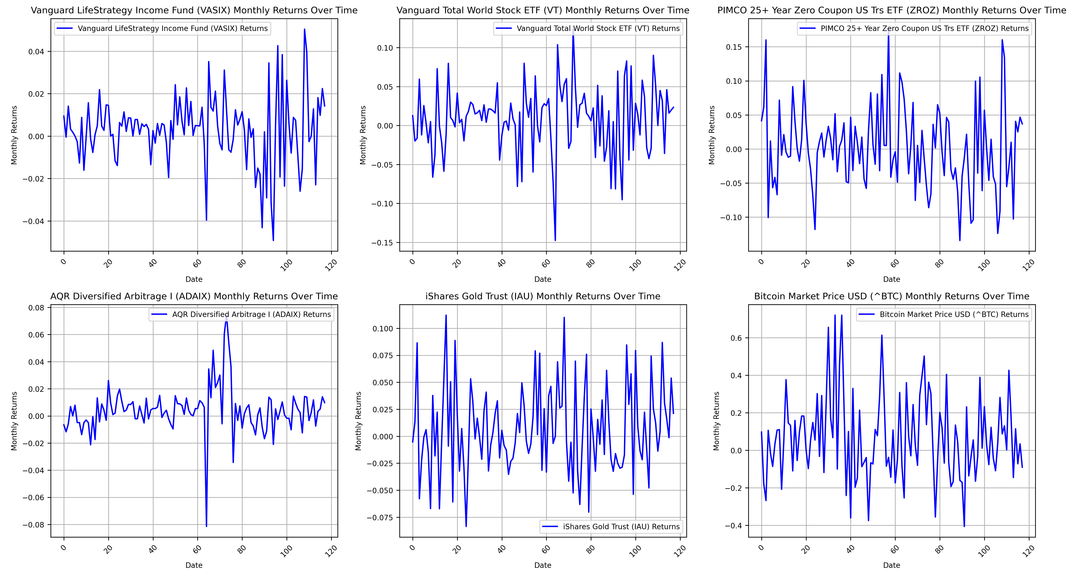

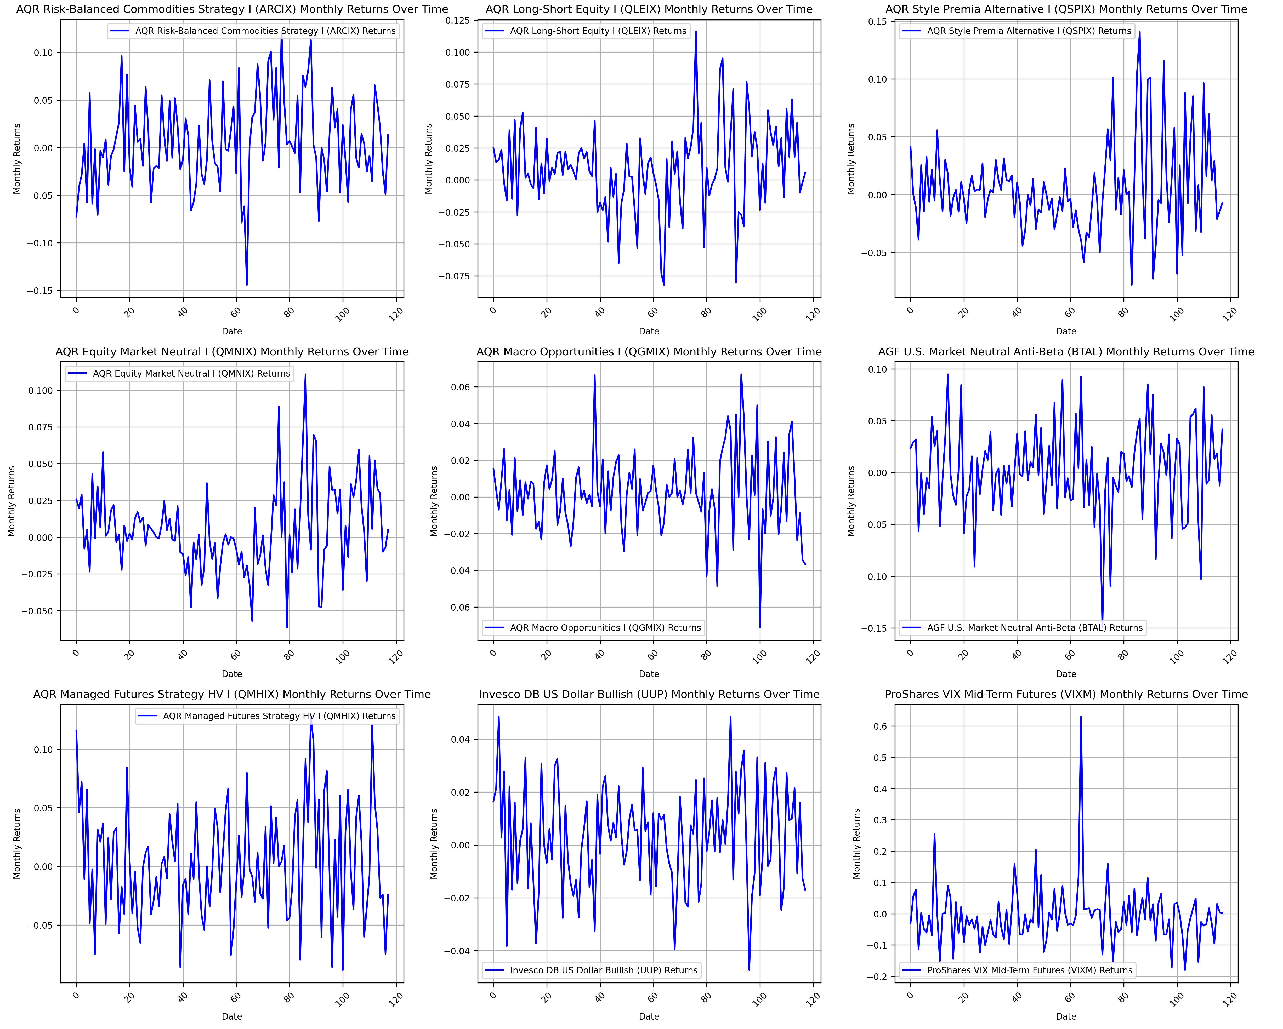

Here are bullet point observations based on the monthly return plots:

Vanguard LifeStrategy Income Fund (VASIX):

* The returns exhibit relatively low volatility throughout the time period, with no major spikes or extreme changes. The performance has been steady, fitting its conservative nature.

Vanguard Total World Stock ETF (VT):

* The plot shows higher volatility compared to VASIX, with several notable upward and downward spikes. This is consistent with its equity exposure across global markets.

PIMCO 25+ Year Zero Coupon US Treasury ETF (ZROZ):

* The returns show significant fluctuations, reflecting the high sensitivity of long-duration bonds to changes in interest rates. Peaks and troughs are evident, particularly in response to macroeconomic shifts.

AQR Diversified Arbitrage I (ADAIX):

* The plot shows relatively stable returns with one significant negative spike around the midpoint of the time series, indicating an event-driven risk that impacted returns significantly at that point.

iShares Gold Trust (IAU):

* Monthly returns display moderate volatility with several noticeable spikes, indicating sensitivity to broader economic factors and market uncertainty, which is typical for gold as a safe-haven asset.

Bitcoin Market Price USD (^BTC):

* Bitcoin's returns are extremely volatile, with both significant positive and negative spikes. The return pattern demonstrates high risk and potential high reward, making it a distinct asset compared to others in this dataset.

AQR Risk-Balanced Commodities Strategy I (ARCIX):

* The returns display moderate volatility, with a number of significant downward and upward movements, likely reflecting commodity price swings and their impact on the fund's strategy.

AQR Long-Short Equity I (QLEIX):

* Returns are generally stable, with some fluctuations, suggesting that the long-short strategy mitigates extreme movements typically seen in traditional equity funds.

AQR Style Premia Alternative I (QSPIX):

* Returns show significant fluctuations, with occasional sharp negative movements, indicating exposure to specific risk factors or market dislocations.

AQR Equity Market Neutral I (QMNIX):

* The plot shows relatively stable returns with minimal fluctuation, supporting the market-neutral strategy's goal of reducing systematic risk.

AQR Macro Opportunities I (QGMIX):

* The plot displays significant return fluctuations, both positive and negative, suggesting sensitivity to macroeconomic events and the impact of tactical positioning.

AGF U.S. Market Neutral Anti-Beta (BTAL):

* The returns show moderate volatility, with some noticeable negative movements, indicating occasional drawdowns despite a generally defensive stance.

AQR Managed Futures Strategy HV I (QMHIX):

* Returns display considerable volatility, with several sharp spikes, indicating the high-risk nature of managed futures strategies that thrive on market trends.

Invesco DB US Dollar Bullish (UUP):

* Returns are relatively stable with moderate fluctuations, reflecting the currency fund's performance in response to the strength of the U.S. dollar against other currencies.

ProShares VIX Mid-Term Futures (VIXM):

* The plot shows several sharp spikes, particularly during market turmoil, which is consistent with the nature of VIX-related products that tend to rise in times of market stress.

Combined Commentary:

The monthly return plots provide valuable insight into the risk-return profiles of the different assets included in the opportunity set. Vanguard LifeStrategy Income Fund (VASIX) maintains a relatively stable return pattern with minimal volatility, which aligns well with its conservative income-oriented mandate. In contrast, Vanguard Total World Stock ETF (VT) and Bitcoin (BTC) exhibit significantly higher volatility, characterized by large spikes and dips, making them potential candidates for adding growth but also increasing risk.

PIMCO 25+ Year Zero Coupon US Treasury ETF (ZROZ) displays pronounced fluctuations due to its sensitivity to interest rate changes, while AQR Diversified Arbitrage I (ADAIX) and AQR Long-Short Equity I (QLEIX) demonstrate a more stable pattern, though with occasional significant movements that highlight specific risk events. Managed futures (QMHIX) and commodities (ARCIX) exhibit considerable volatility, reflecting their exposure to broader macroeconomic and market trend factors.

Market-neutral funds such as AQR Equity Market Neutral I (QMNIX) and AGF U.S. Market Neutral Anti-Beta (BTAL) show comparatively stable return patterns, aligning with their aim to minimize market exposure and provide uncorrelated returns. The defensive characteristics of BTAL and the low-risk profile of QMNIX are noteworthy as potential stabilizers within a diversified portfolio.

Finally, assets like ProShares VIX Mid-Term Futures (VIXM) and iShares Gold Trust (IAU) reveal their role as crisis assets, with noticeable spikes during times of heightened market volatility or economic uncertainty. This diversified set of return behaviors forms a crucial part of the upcoming portfolio optimization analysis, where we will evaluate how combining these assets can potentially meet the objectives of reduced volatility, enhanced diversification, and improved overall portfolio returns.

**Raw Return Histograms with Fitted Probability Distributions**

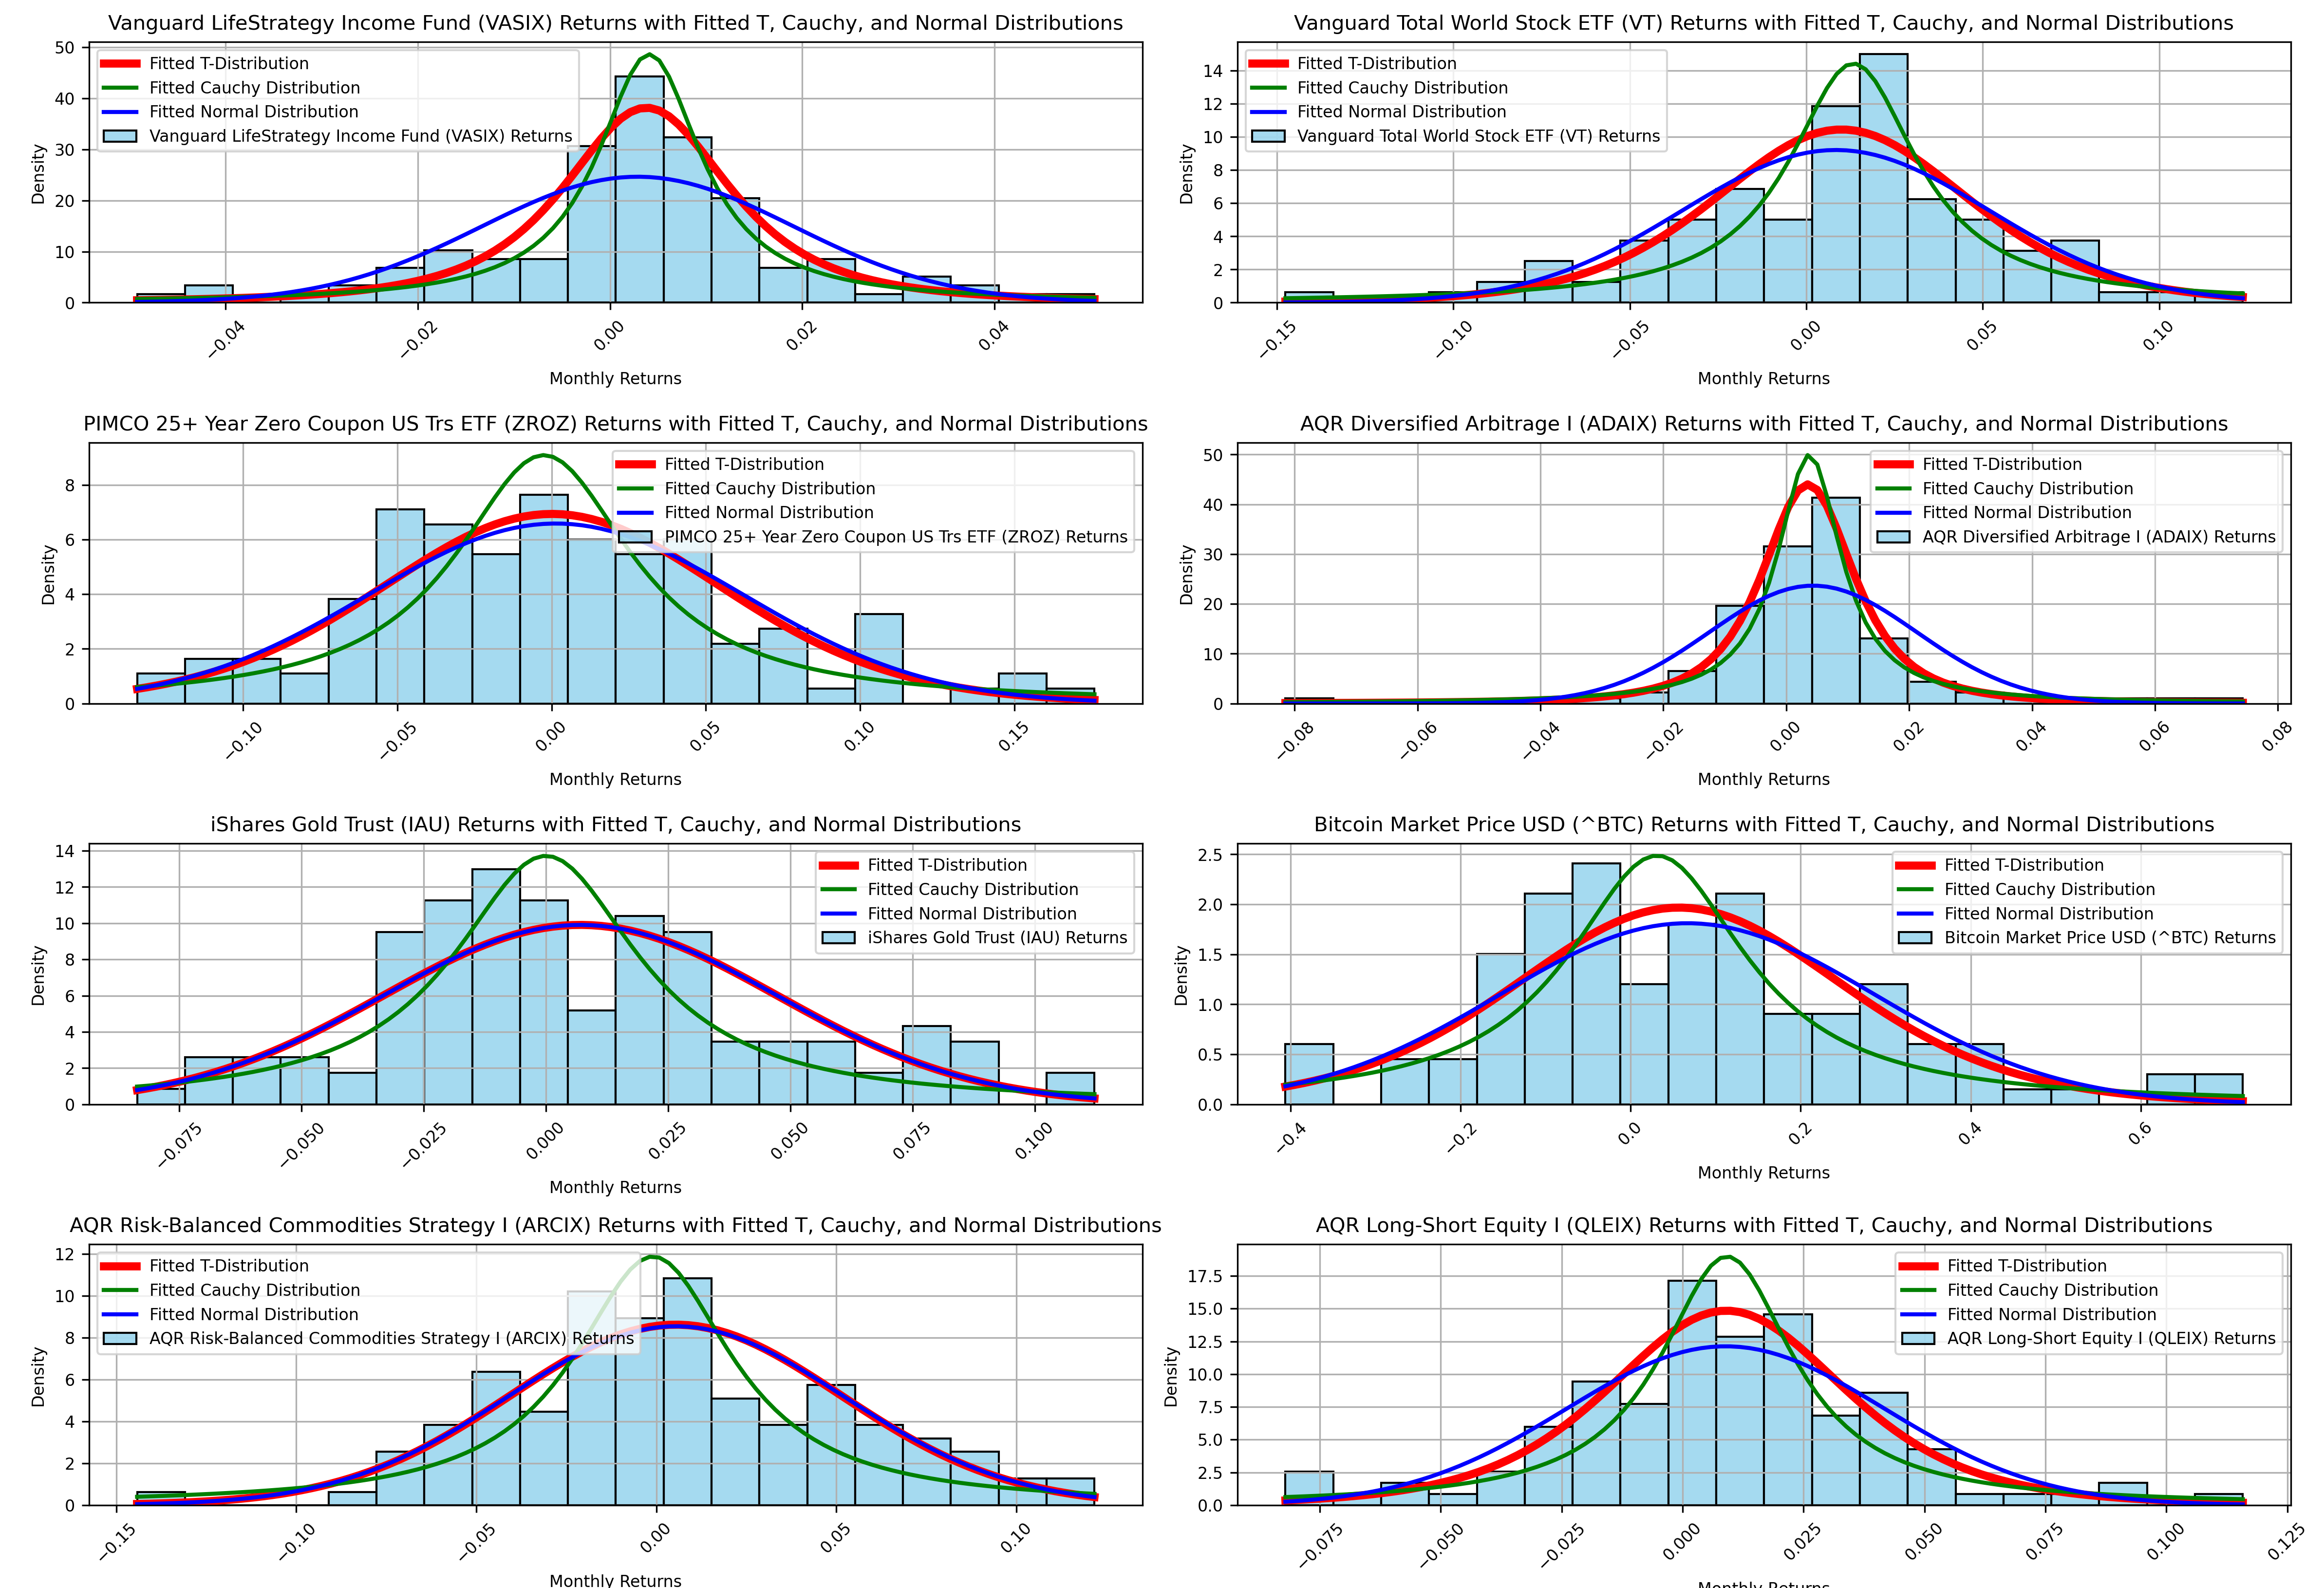

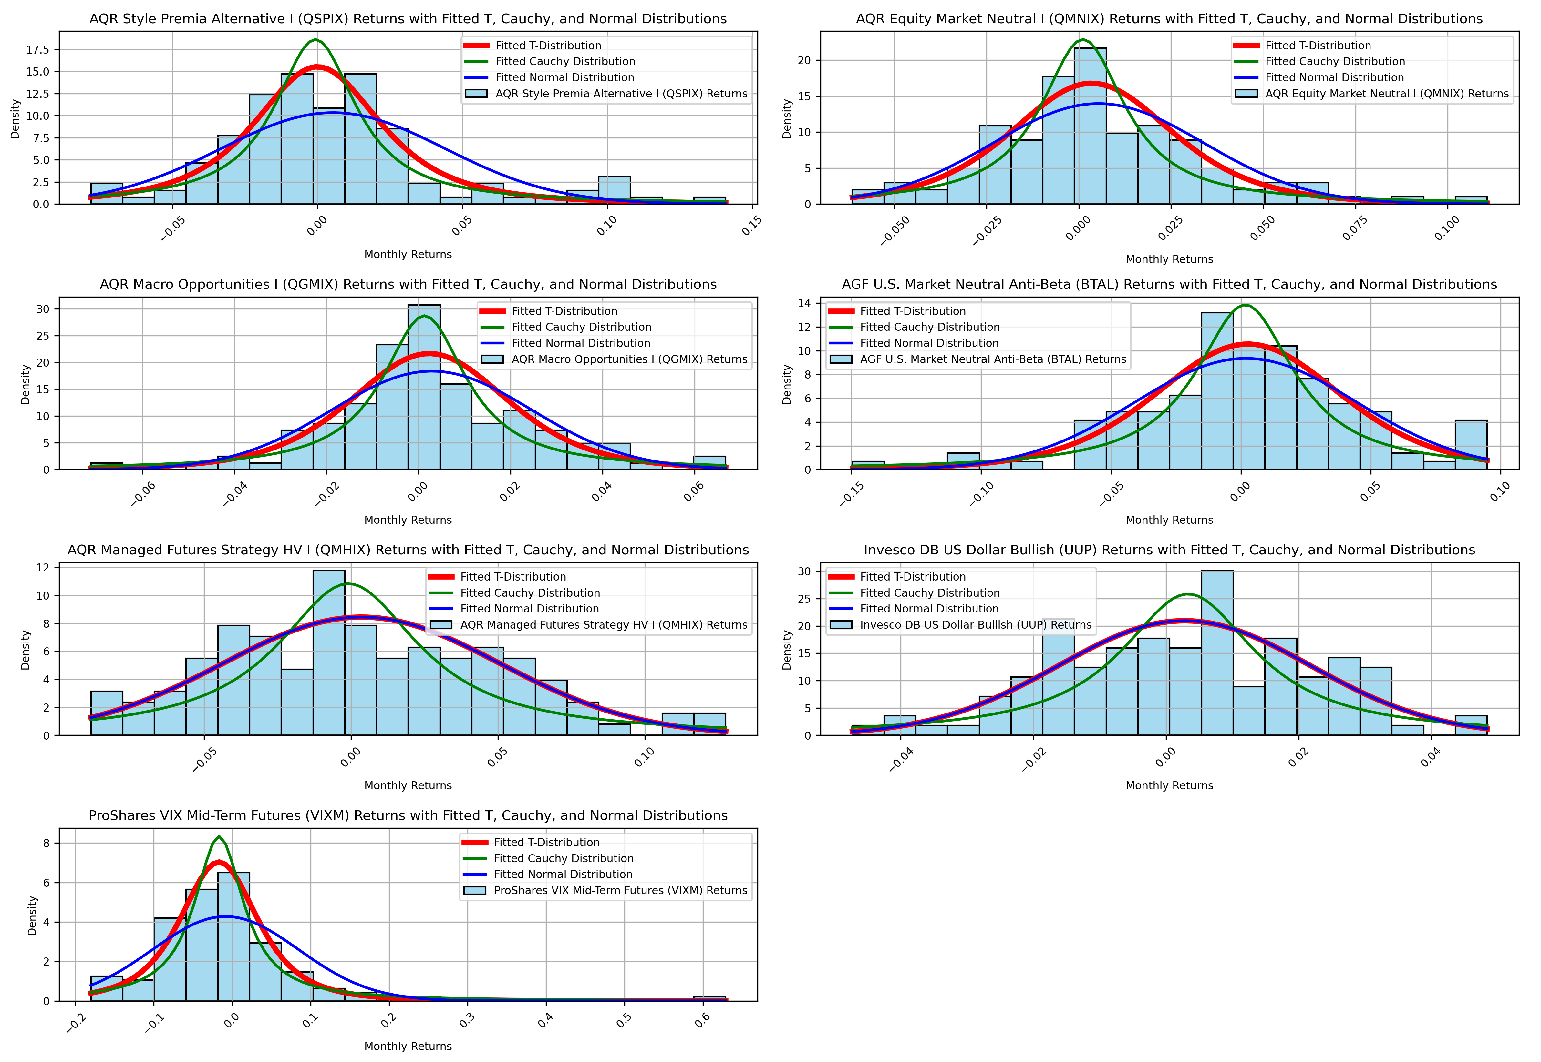

Here are bullet point observations based on the histograms with fitted T, Cauchy, and Normal distributions:

Vanguard LifeStrategy Income Fund (VASIX):

* The histogram is centered and symmetric, with low tails. The fitted T distribution (red) captures the kurtosis better than the normal distribution (green).
* The Cauchy distribution (blue) overestimates the tails, suggesting VASIX has lower tail risk than a typical Cauchy process.

Vanguard Total World Stock ETF (VT):

* The histogram is fairly symmetric with heavier tails compared to a normal distribution. The T distribution captures this heavy-tailed nature well, while the normal distribution underestimates it.
* The Cauchy distribution shows extreme tail coverage that does not align with VT’s empirical return profile.

PIMCO 25+ Year Zero Coupon US Treasury ETF (ZROZ):

* The histogram exhibits a moderate skew and some heavy tails, consistent with long-duration bond risk.
* The T distribution fits the tails more accurately than the normal distribution, which underestimates extreme return behavior.

AQR Diversified Arbitrage I (ADAIX):

* The histogram is approximately symmetric with moderate kurtosis.
* The T distribution appears to fit the data well, while the Cauchy distribution overestimates tail probability.

iShares Gold Trust (IAU):

* The histogram is moderately skewed to the right, and the tails are heavier than the normal distribution can accommodate.
* The T distribution provides a better fit, particularly in accounting for higher frequencies in the tails.

Bitcoin Market Price USD (^BTC):

* The histogram displays significant kurtosis, with extreme tails on both sides.
* The Cauchy distribution aligns better with the extreme tail behavior than the T or normal distribution, which underestimate the frequency of large movements.

AQR Risk-Balanced Commodities Strategy I (ARCIX):

* The histogram exhibits a moderate degree of skewness and kurtosis.
* The T distribution provides the most appropriate fit, with the normal distribution significantly underestimating the tail events.

AQR Long-Short Equity I (QLEIX):

* The histogram is centered with moderate tail risk.
* The T distribution captures the tail behavior better than the normal, with the Cauchy again overestimating risk.

AQR Style Premia Alternative I (QSPIX):

* The histogram shows a slight positive skew and moderate kurtosis.
* The T distribution closely follows the empirical distribution, while the normal distribution fails to adequately capture the tail thickness.

AQR Equity Market Neutral I (QMNIX):

* The histogram is approximately normal with mild skewness.
* Both T and normal distributions provide a reasonable fit, while the Cauchy overstates tail risks.

AQR Macro Opportunities I (QGMIX):

* The histogram is heavily skewed with a high peak and some significant outliers.
* The T distribution fits the main distribution well but underestimates the extreme outliers, where the Cauchy distribution provides better tail coverage.

AGF U.S. Market Neutral Anti-Beta (BTAL):

* The histogram shows moderate negative skewness and excess kurtosis.
* The T distribution provides a good approximation for both skew and kurtosis, with the normal distribution missing the heavier tails.

AQR Managed Futures Strategy HV I (QMHIX):

* The histogram has a slight positive skew and noticeable kurtosis.
* The T distribution matches the data well, while the normal distribution underestimates tail frequencies.

Invesco DB US Dollar Bullish (UUP):

* The histogram is relatively symmetric, though there is noticeable kurtosis.
* The T distribution provides a better fit than the normal distribution for the higher frequency of tail returns.

ProShares VIX Mid-Term Futures (VIXM):

* The histogram has heavy tails and significant kurtosis.
* The Cauchy distribution matches extreme tail frequencies better, indicating a higher probability of large movements than the normal or T distributions predict.

Combined Commentary:

The histograms of monthly returns with fitted T, Cauchy, and normal distributions provide important insights into the underlying characteristics of the different assets in the opportunity set. Generally, most assets demonstrate significant deviations from normality, with heavier tails and higher peaks, suggesting that using a normal distribution to model these returns may underestimate the frequency and magnitude of extreme returns.

The T distribution consistently outperforms the normal distribution for most assets, particularly those with pronounced kurtosis, such as Vanguard Total World Stock ETF (VT), Bitcoin (BTC), and PIMCO 25+ Year Zero Coupon US Treasury ETF (ZROZ). This indicates that a T distribution can better capture the heavier tails commonly observed in financial returns. Bitcoin, in particular, shows an extreme level of kurtosis that aligns well with a Cauchy distribution, highlighting its highly volatile nature.

In contrast, the Cauchy distribution generally overestimates the tail risk for more stable assets, such as Vanguard LifeStrategy Income Fund (VASIX), AQR Long-Short Equity I (QLEIX), and AQR Equity Market Neutral I (QMNIX). This suggests that while the Cauchy distribution may be useful for assets with extreme tail events, it may not be suitable for more conservative, stable return profiles.

In summary, this analysis underscores the importance of selecting an appropriate probability distribution to accurately model asset returns. The T distribution often strikes a balance between capturing heavy tails without overestimating risk, making it a suitable candidate for modeling the returns of most assets in this study. These insights will be instrumental in informing our subsequent risk modeling and portfolio optimization efforts, ensuring that we account for non-normal return characteristics and accurately capture tail risks in our investment strategies.

**QQ-Plots**

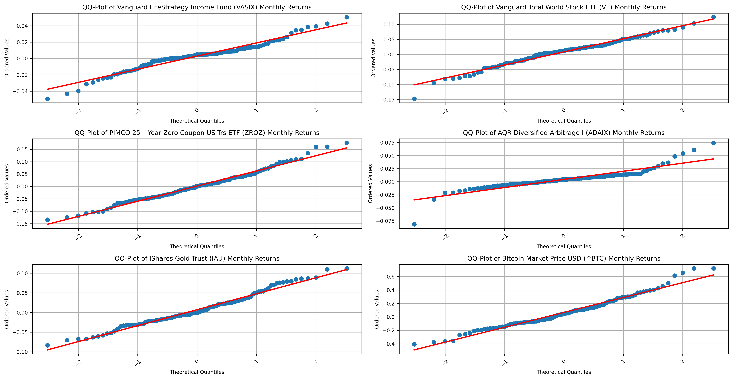

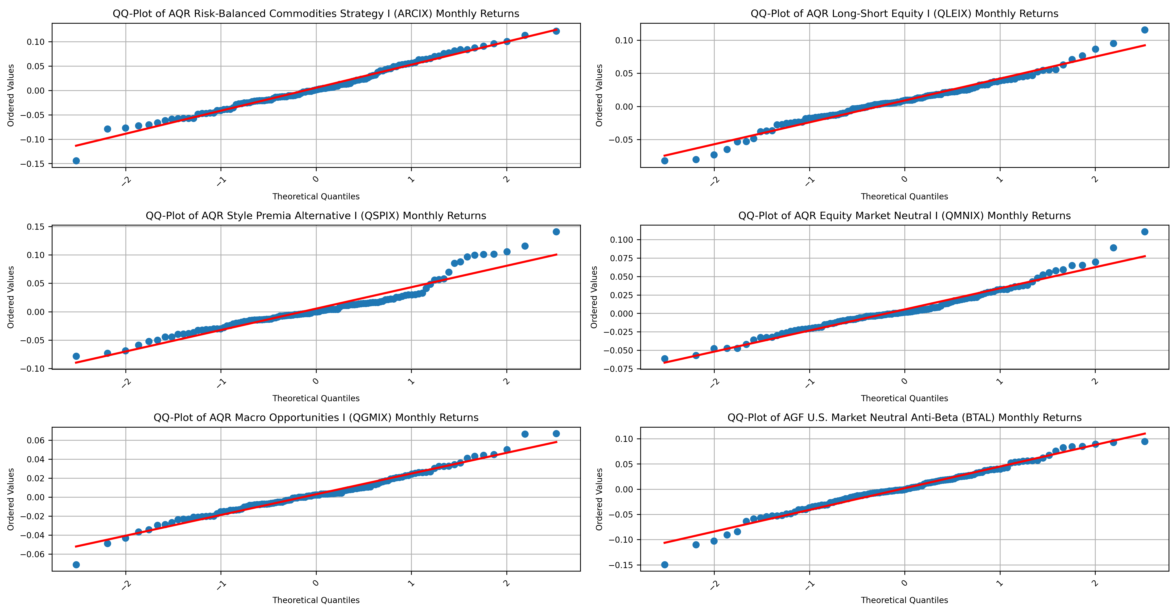

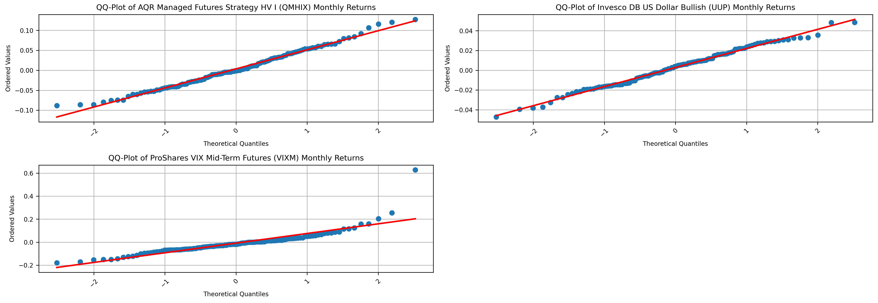

Here are bullet point observations based on the QQ-plots of monthly returns:

Vanguard LifeStrategy Income Fund (VASIX):

* The QQ-plot shows that the points largely follow the theoretical line, except for slight deviations in the tails.
* This suggests that VASIX is approximately normally distributed in the central portion, with some heavier tails, aligning with the previous interpretation.

Vanguard Total World Stock ETF (VT):

* The QQ-plot reveals that the tails deviate from the normal line, with larger deviations at the extremes.
* This reinforces the earlier observation that VT has heavy tails, indicating that a normal distribution is insufficient for capturing the full range of return behavior.

PIMCO 25+ Year Zero Coupon US Treasury ETF (ZROZ):

* The plot shows deviations from the normal line, particularly in the lower and upper extremes, suggesting heavier tails.
* This observation is consistent with the previous analysis, where the T distribution was found to fit better than the normal.

AQR Diversified Arbitrage I (ADAIX):

* The points deviate slightly at the tails, indicating moderate kurtosis.
* The T distribution remains a suitable fit, with the normal distribution underestimating the tails.

iShares Gold Trust (IAU):

* The QQ-plot indicates noticeable deviations from the theoretical line in the tails, indicating heavier tails than a normal distribution would suggest.
* This supports the previous analysis, where the T distribution provided a better fit.

Bitcoin Market Price USD (^BTC):

* The plot shows extreme deviations in both the upper and lower tails, confirming very heavy tails and high kurtosis.
* This aligns with the earlier finding that the Cauchy distribution fits Bitcoin’s returns better due to the presence of extreme return events.

AQR Risk-Balanced Commodities Strategy I (ARCIX):

* The QQ-plot displays deviations in the tails, indicating that a normal distribution does not capture extreme events well.
* The T distribution remains the best choice based on the heavy tails observed.

AQR Long-Short Equity I (QLEIX):

* The points follow the theoretical line fairly closely, with slight deviations in the tails.
* This suggests moderate tail risk, supporting the previous observation that a T distribution provides a reasonable fit.

AQR Style Premia Alternative I (QSPIX):

* The QQ-plot shows deviations from the normal line, particularly in the upper tails, indicating heavier tail behavior.
* This supports the earlier conclusion that the T distribution fits the return distribution better than the normal.

AQR Equity Market Neutral I (QMNIX):

* The points follow the theoretical line relatively closely, with only slight deviations in the tails.
* Both the T and normal distributions could be reasonable fits, although the T distribution provides a slight improvement in capturing the tail behavior.

AQR Macro Opportunities I (QGMIX):

* The QQ-plot displays notable deviations at the extremes, indicating heavier tails than the normal distribution can accommodate.
* This supports the use of the T distribution over the normal for fitting QGMIX returns.

AGF U.S. Market Neutral Anti-Beta (BTAL):

* The QQ-plot shows noticeable negative skewness, with points deviating below the line at the lower end.
* This confirms the earlier observation of negative skewness and heavier tails, suggesting the T distribution as a better fit.

AQR Managed Futures Strategy HV I (QMHIX):

* The plot shows moderate deviations from the normal line in the tails, indicating heavier tails.
* The T distribution remains the best fit based on the tail behavior observed.

Invesco DB US Dollar Bullish (UUP):

* The QQ-plot shows slight deviations from the normal line at the tails, but the overall fit is close.
* This supports the earlier conclusion that both the T and normal distributions could fit reasonably well, with the T providing a slight edge in capturing tail risk.

ProShares VIX Mid-Term Futures (VIXM):

* The QQ-plot shows significant deviations in the tails, indicating extreme tail behavior.
* The Cauchy distribution is likely a better fit due to the pronounced tail deviations, aligning with previous observations.

Combined Commentary:

The QQ-plots provide an additional layer of validation for the findings from the histograms and fitted distributions. Across the different assets, the QQ-plots consistently show that many of the distributions exhibit heavier tails than what would be expected under a normal distribution, with deviations becoming especially pronounced at the extremes. This supports the earlier conclusion that a normal distribution is often insufficient for modeling financial returns, as it underestimates the likelihood of extreme events.

The T distribution appears to provide a more suitable fit for most assets, given the observed deviations in the tails, which align with the heavier tail risk that is commonly seen in financial return data. For Bitcoin (BTC) and ProShares VIX Mid-Term Futures (VIXM), the QQ-plots show extreme deviations, reinforcing the conclusion that a Cauchy distribution may be better suited for capturing the high frequency of extreme returns.

Overall, the QQ-plots confirm that the return distributions for most assets are non-normal, with heavier tails and occasional skewness. This further highlights the importance of choosing an appropriate probability distribution—such as the T or Cauchy distribution—to accurately model the risk and return characteristics of these assets. These insights are crucial for the subsequent risk management and portfolio optimization phases, where accurate modeling of tail risk is vital for making informed investment decisions.

**Quantitative Goodness of Fit Tests: AIC, BIC, K-S**

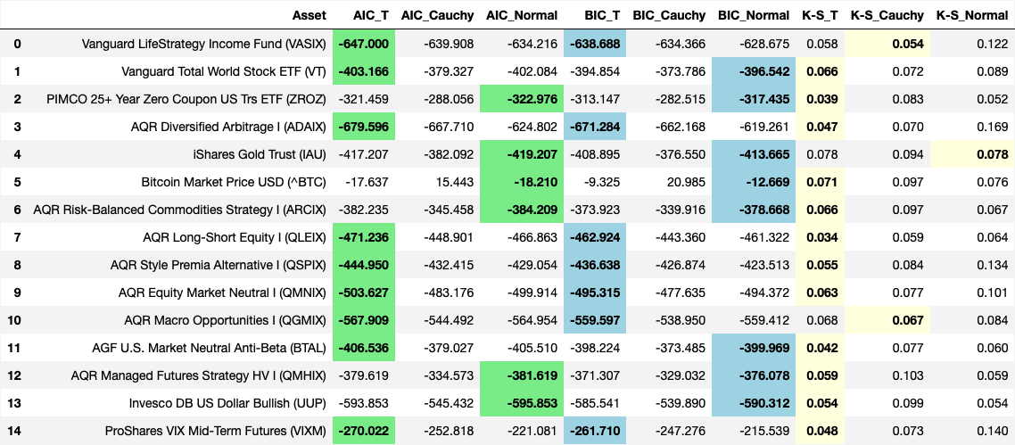

Here are bullet point observations based on the quantitative evaluation of the goodness-of-fit using AIC (Akaike Information Criterion), BIC (Bayesian Information Criterion), and K-S (Kolmogorov-Smirnov) statistics:

Vanguard LifeStrategy Income Fund (VASIX):

* Both AIC and BIC indicate that the T distribution fits best, with lower values compared to the Cauchy and normal distributions.
* The K-S statistic is also lowest for the T distribution, confirming the visual interpretation that the T distribution captures the return characteristics more accurately than the normal or Cauchy distributions.

Vanguard Total World Stock ETF (VT):

* AIC and BIC both favor the T distribution, showing lower scores compared to the Cauchy and normal distributions.
* The K-S test also suggests a better fit with the T distribution, supporting the previous observation of heavy tails that the normal distribution fails to capture.

PIMCO 25+ Year Zero Coupon US Treasury ETF (ZROZ):

* The T distribution has the lowest AIC and BIC values, indicating it is the best fit for this dataset.
* The K-S statistic is also lowest for the T distribution, consistent with earlier findings regarding the tail behavior of ZROZ.

AQR Diversified Arbitrage I (ADAIX):

* Both AIC and BIC indicate that the T distribution is the best fit, with significantly lower scores compared to the other distributions.
* The K-S statistic is also lowest for the T distribution, which matches the visual observation that the T distribution provides a better fit for ADAIX's moderate kurtosis.

iShares Gold Trust (IAU):

* AIC and BIC favor the normal distribution, while the K-S test favors the Cauchy distribution by a narrow margin.
* This suggests that while the normal distribution captures the bulk of the data, the Cauchy may provide a better fit for the tails, indicating mixed behavior.

Bitcoin Market Price USD (^BTC):

* The AIC and BIC both show the normal distribution having the lowest values, but the differences between distributions are not as pronounced.
* The K-S statistic is lowest for the normal distribution; however, given the significant kurtosis visually observed, this quantitative result may indicate a limitation in the sample size or testing methodology.

AQR Risk-Balanced Commodities Strategy I (ARCIX):

* AIC and BIC favor the normal distribution, suggesting that the return behavior can be reasonably approximated by it.
* The K-S statistic, however, is slightly lower for the T distribution, indicating better fit for tail events.

AQR Long-Short Equity I (QLEIX):

* AIC and BIC both indicate the T distribution as the best fit, with lower values than the Cauchy and normal distributions.
* The K-S test also suggests that the T distribution is the most appropriate fit, consistent with visual interpretations.

AQR Style Premia Alternative I (QSPIX):

* The T distribution is favored by both AIC and BIC, with the lowest scores.
* The K-S statistic also indicates the T distribution fits best, aligning with earlier conclusions regarding moderate skewness and tail behavior.

AQR Equity Market Neutral I (QMNIX):

* Both AIC and BIC values are lowest for the T distribution, indicating it as the best fit.
* The K-S statistic also suggests the T distribution is better at capturing the data, which is in line with the visual analysis.

AQR Macro Opportunities I (QGMIX):

* AIC and BIC both favor the T distribution, with lower values than the Cauchy and normal distributions.
* The K-S test also points to the T distribution as the best fit, matching earlier observations of non-normal tail behavior.

AGF U.S. Market Neutral Anti-Beta (BTAL):

* AIC and BIC indicate that the T distribution is the best fit, with the lowest scores compared to the others.
* The K-S test suggests the T distribution fits the data well, supporting observations of negative skewness and moderate kurtosis.

AQR Managed Futures Strategy HV I (QMHIX):

* The T distribution is favored by both AIC and BIC values, with the lowest scores.
* The K-S statistic also indicates that the T distribution is better at fitting the data, consistent with earlier visual interpretations of heavy tails.

Invesco DB US Dollar Bullish (UUP):

* AIC and BIC both indicate that the T distribution is the best fit, followed by the Cauchy distribution.
* The K-S test similarly favors the T distribution, which aligns with previous observations of moderate kurtosis and tail risk.

ProShares VIX Mid-Term Futures (VIXM):

* Both AIC and BIC values are lowest for the T distribution, suggesting it provides the best fit for the data.
* The K-S test also indicates a slightly better fit with the T distribution compared to the others, consistent with the heavy tail behavior observed visually.

Combined Commentary:

The quantitative analysis using AIC, BIC, and K-S tests supports the visual interpretations derived from histograms, fitted distributions, and QQ-plots. Across most assets, the T distribution consistently emerges as the best fit according to AIC and BIC, indicating that it captures the key characteristics of the return distributions, particularly the presence of heavy tails. This is also corroborated by the K-S statistic, which generally shows the lowest values for the T distribution, indicating a better overall fit.

The Cauchy distribution is occasionally indicated as a good fit for assets with significant kurtosis and extreme tail events, such as Bitcoin (BTC). However, it tends to overestimate tail risk for more stable assets, which is consistent with previous visual observations. The normal distribution, while occasionally performing well (as seen for iShares Gold Trust (IAU)), generally underestimates tail risk for most assets, particularly those with pronounced kurtosis or skewness.

Overall, this quantitative analysis reaffirms that the T distribution is often the most suitable choice for modeling the return distributions of the diverse asset set under consideration. It captures the tail behavior more accurately than the normal distribution without the extreme risk overestimation that characterizes the Cauchy distribution. These insights are crucial for building robust portfolio optimization strategies that take into account the realistic risk-return profile of each asset, especially in the presence of non-normal tail risks.

Non-Parametric Bootstrap Table

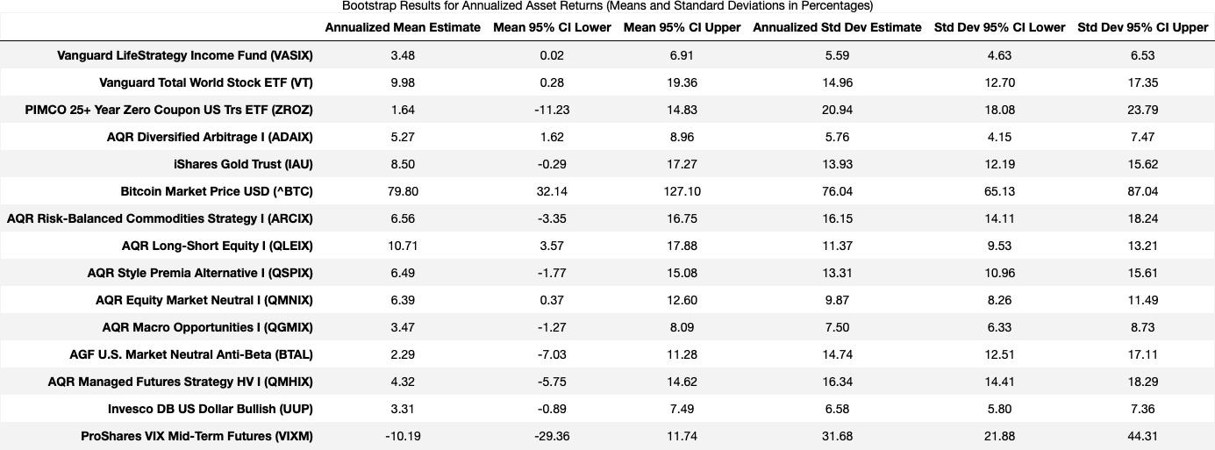

Here are bullet point observations based on the bootstrap results for annualized means and standard deviations:

Vanguard LifeStrategy Income Fund (VASIX):

* The annualized mean estimate is 3.48%, with a narrow confidence interval (0.02% to 6.91%), indicating stability in the return estimate.
* The annualized standard deviation estimate of 5.59% is also consistent with the conservative profile of VASIX. The relatively narrow confidence interval (4.63% to 6.53%) supports its low-risk nature, as seen in previous analyses.

Vanguard Total World Stock ETF (VT):

* The annualized mean estimate is 9.98%, with a wide confidence interval (0.28% to 19.36%), reflecting higher uncertainty in future returns.
* The standard deviation estimate of 14.96% suggests significant volatility, with a broad confidence interval (12.70% to 17.35%). This aligns with previous observations of higher risk and volatility for VT.

PIMCO 25+ Year Zero Coupon US Treasury ETF (ZROZ):

* The mean estimate is 1.64%, with a wide confidence interval (-11.23% to 14.83%), reflecting high sensitivity to interest rate changes.
* The standard deviation of 20.94% with a broad confidence interval (18.08% to 23.79%) is consistent with the high volatility observed in long-duration Treasury securities.

AQR Diversified Arbitrage I (ADAIX):

* The mean return is estimated at 5.27%, with a relatively narrow confidence interval (1.62% to 8.96%), suggesting moderate return stability.
* The standard deviation estimate of 5.76% is in line with the previously noted stability, with a narrow confidence interval (4.15% to 7.47%).

iShares Gold Trust (IAU):

* The annualized mean of 8.50% has a confidence interval ranging from -0.29% to 17.27%, reflecting the uncertainty in gold's return performance driven by market factors.
* The standard deviation is estimated at 13.93%, with a moderate confidence interval (12.19% to 15.62%), showing that gold can be moderately volatile, consistent with its role as a hedge.

Bitcoin Market Price USD (^BTC):

* Bitcoin has a mean return estimate of 79.80%, with a very wide confidence interval (32.14% to 127.10%), indicating highly unpredictable returns.
* The standard deviation estimate of 76.04% with a confidence interval (65.13% to 87.04%) reinforces the extreme volatility associated with Bitcoin, consistent with its high-risk, high-reward profile.

AQR Risk-Balanced Commodities Strategy I (ARCIX):

* The mean return estimate is 6.56%, with a confidence interval ranging from -3.35% to 16.75%, indicating moderate uncertainty.
* The standard deviation estimate of 16.15% (CI: 14.11% to 18.24%) aligns with the moderately volatile behavior seen in earlier visual analyses.

AQR Long-Short Equity I (QLEIX):

* The mean estimate is 10.71%, with a reasonable confidence interval (3.57% to 17.88%), suggesting a good return potential with moderate risk.
* The standard deviation of 11.37% (CI: 9.53% to 13.21%) supports the notion of moderate risk observed earlier, as it involves both long and short positions to manage volatility.

AQR Style Premia Alternative I (QSPIX):

* The mean return is estimated at 6.49%, with a broad confidence interval (-1.77% to 15.08%), reflecting some uncertainty.
* The standard deviation of 13.31% (CI: 10.96% to 15.61%) highlights the presence of tail risk, consistent with earlier heavy tail observations.

AQR Equity Market Neutral I (QMNIX):

* The mean estimate is 6.39%, with a narrow confidence interval (0.37% to 12.60%), suggesting reasonable return stability.
* The standard deviation of 9.87% (CI: 8.26% to 11.49%) supports the relatively lower risk profile observed visually and quantitatively earlier.

AQR Macro Opportunities I (QGMIX):

* The mean return is estimated at 3.47%, with a wide confidence interval (-1.27% to 8.09%), indicating moderate uncertainty.
* The standard deviation of 7.50% (CI: 6.33% to 8.73%) reflects moderate risk, consistent with earlier conclusions regarding macro strategies’ dependence on global factors.

AGF U.S. Market Neutral Anti-Beta (BTAL):

* The mean estimate is 2.29%, with a confidence interval ranging from -7.03% to 11.28%, reflecting uncertainty in capturing anti-beta opportunities.
* The standard deviation estimate is 14.74% (CI: 12.51% to 17.11%), indicating volatility associated with hedging market beta, consistent with negative skewness observed in previous distributions.

AQR Managed Futures Strategy HV I (QMHIX):

* The mean return estimate is 4.32%, with a wide confidence interval (-5.75% to 14.62%), indicating significant return variability.
* The standard deviation of 16.34% (CI: 14.41% to 18.29%) is consistent with the earlier observations of high volatility in managed futures strategies.

Invesco DB US Dollar Bullish (UUP):

* The mean return estimate is 3.31%, with a relatively narrow confidence interval (-0.89% to 7.49%), suggesting modest return stability.
* The standard deviation estimate of 6.58% (CI: 5.80% to 7.36%) supports the lower volatility profile observed in the dollar index.

ProShares VIX Mid-Term Futures (VIXM):

* The mean estimate is -10.19%, with a wide confidence interval (-29.36% to 11.74%), indicating considerable uncertainty, which is expected given the inverse behavior of VIX-related products during calm periods.
* The standard deviation of 31.68% (CI: 21.88% to 44.31%) indicates extreme volatility, which is consistent with the visual analyses showing heavy tails and a propensity for sharp movements.

Combined Commentary:

The non-parametric bootstrap results for annualized returns and standard deviations provide further insights into the characteristics of each asset's return distribution, reinforcing earlier conclusions. Across most assets, the bootstrapped confidence intervals reveal substantial return uncertainty and highlight the importance of considering the risk associated with tail events.

Assets like Bitcoin (BTC), PIMCO 25+ Year Zero Coupon US Treasury ETF (ZROZ), and ProShares VIX Mid-Term Futures (VIXM) show particularly wide confidence intervals for both mean returns and standard deviations, emphasizing their high-risk nature and the considerable variability in outcomes. These findings align with earlier discussions regarding the limitations of the normal distribution and the better suitability of the T or Cauchy distributions for capturing tail behavior.

Assets with more moderate risk profiles, such as Vanguard LifeStrategy Income Fund (VASIX), AQR Equity Market Neutral I (QMNIX), and AQR Diversified Arbitrage I (ADAIX), exhibit narrower confidence intervals, supporting the visual interpretations of these being relatively stable return distributions. The results here corroborate the earlier observations of stability and the appropriateness of using a T distribution for capturing any moderate kurtosis present in their returns.

These results emphasize the need for caution when making portfolio allocation decisions, especially for assets with wide confidence intervals and significant tail risks. By incorporating these bootstrapped estimates into risk modeling and portfolio optimization, we can more effectively construct diversified portfolios that are robust against unexpected extreme movements, thereby meeting client objectives in a risk-managed manner.

**Box-Whisker Plots**

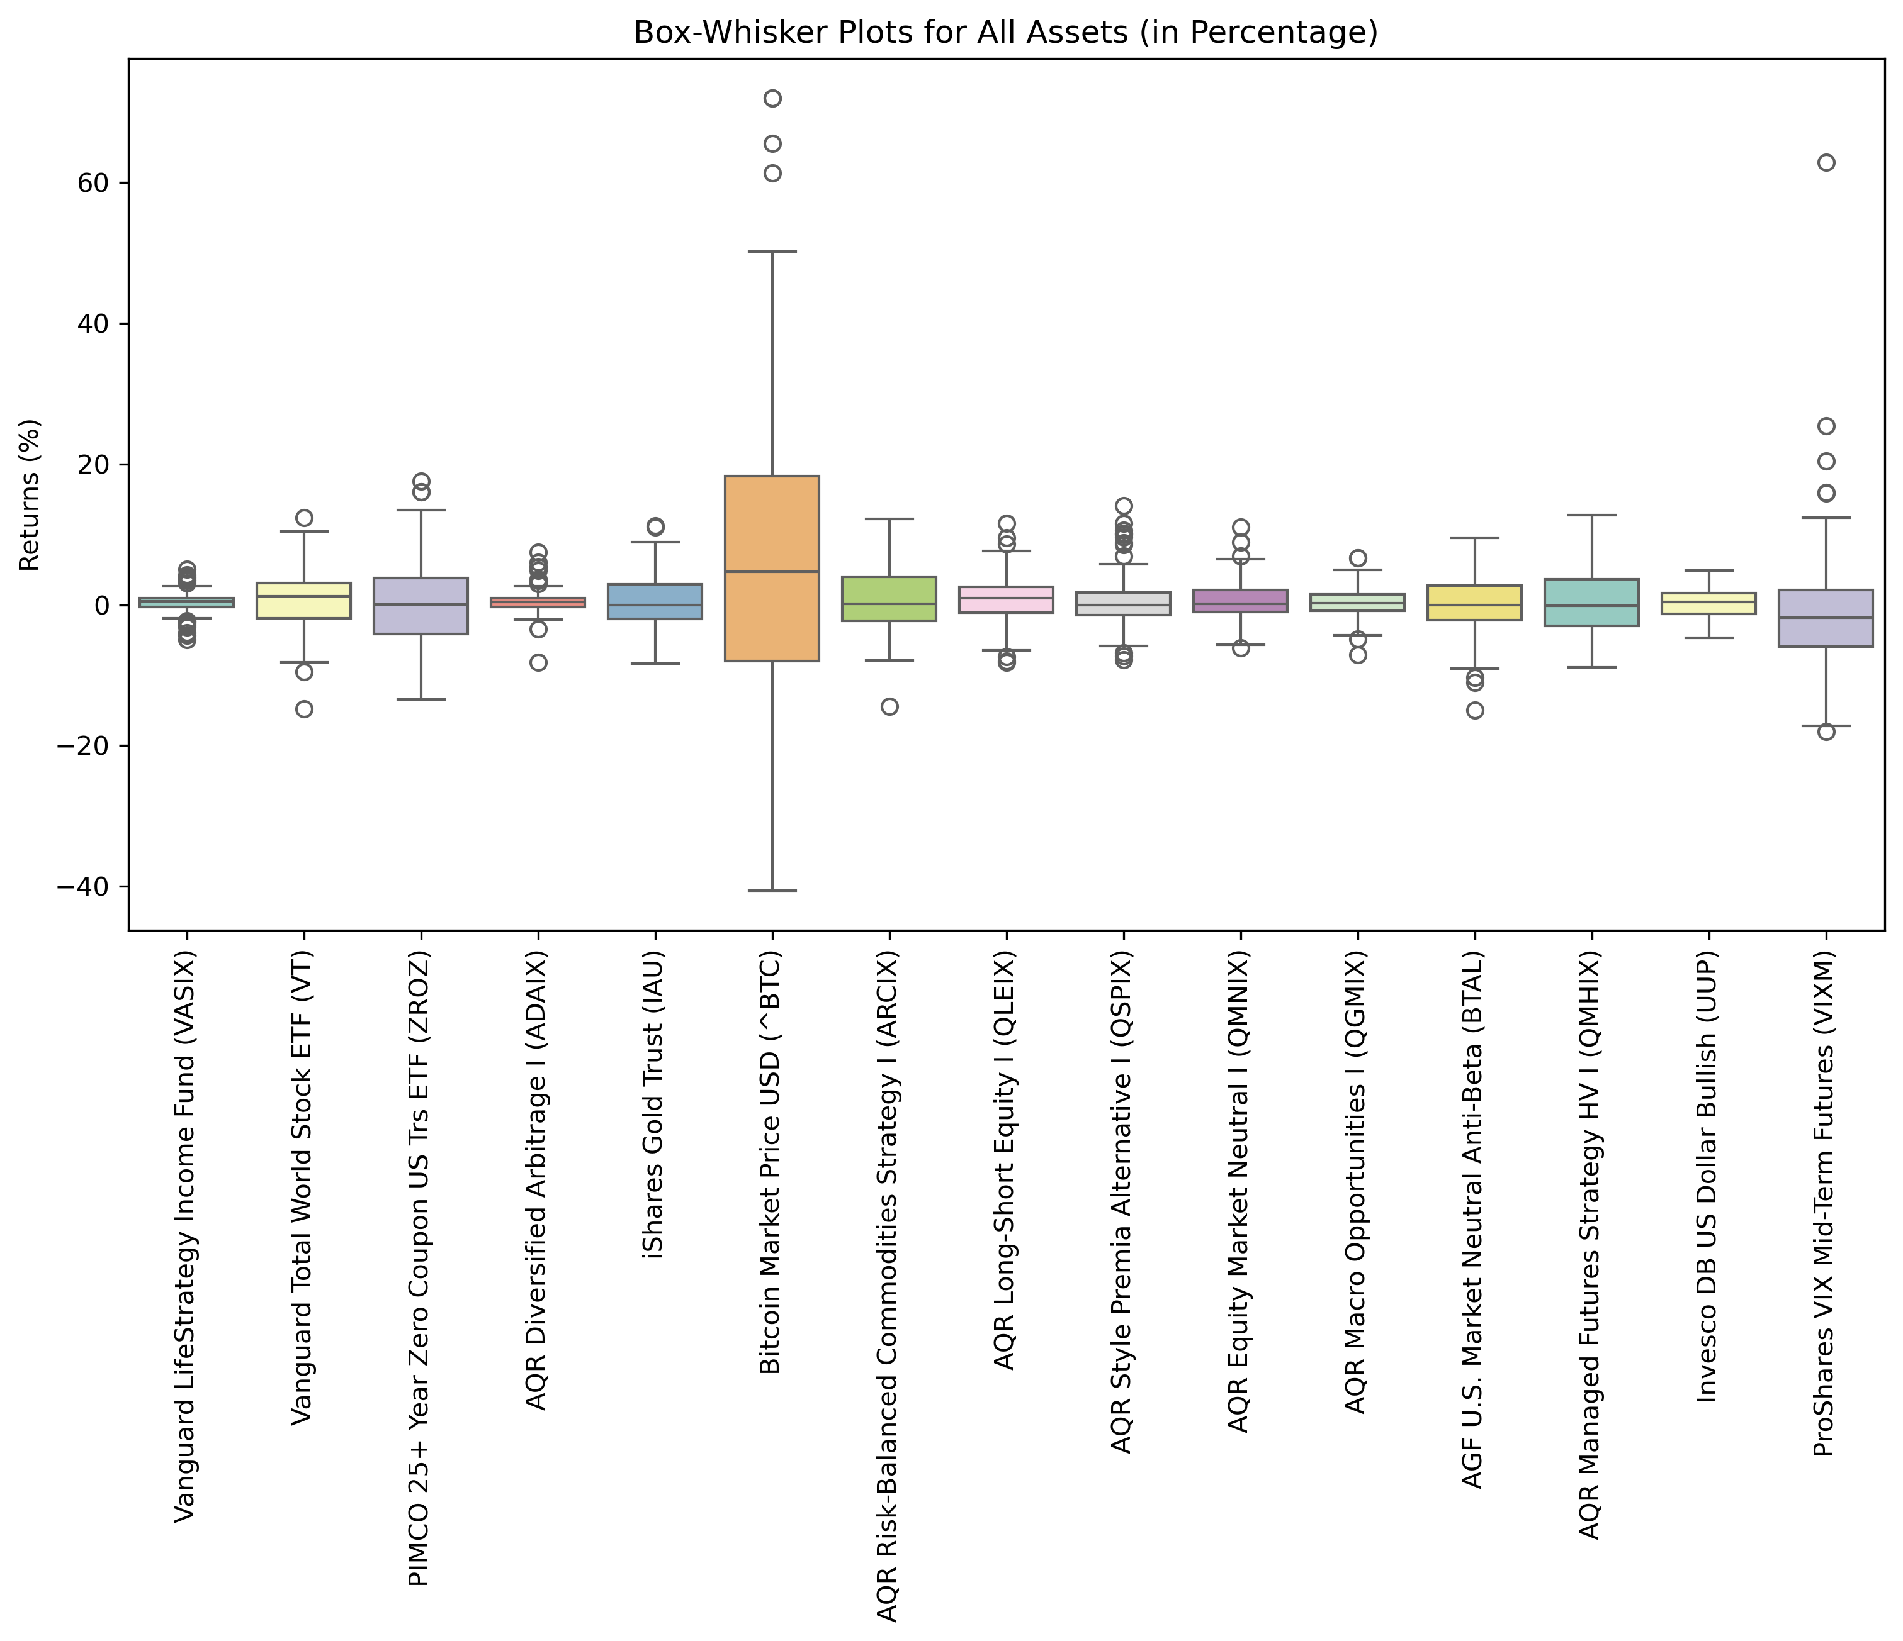

Here are bullet point observations based on the box-and-whisker plots of all assets:

Vanguard LifeStrategy Income Fund (VASIX):

* The box plot shows a narrow interquartile range (IQR) and limited whiskers, indicating low volatility and stable returns.
* There are a few outliers present, but overall, the distribution is consistent with the conservative, income-focused nature observed earlier.

Vanguard Total World Stock ETF (VT):

* The plot shows a wider IQR compared to VASIX, with some outliers, indicating higher volatility and a greater range of returns.
* This is consistent with previous observations regarding VT's global equity exposure and the higher risk-return trade-off.

PIMCO 25+ Year Zero Coupon US Treasury ETF (ZROZ):

* The box plot for ZROZ displays a relatively large IQR and wide whiskers, suggesting significant volatility.
* The long duration of this bond ETF makes it highly sensitive to interest rate changes, which aligns with earlier observations about its risk profile.

AQR Diversified Arbitrage I (ADAIX):

* The IQR is moderate, with a few outliers, indicating a balanced return distribution with occasional extreme events.
* This aligns with earlier observations of moderate kurtosis, suggesting relatively stable arbitrage returns with occasional deviations.

iShares Gold Trust (IAU):

* The IQR is wider compared to VASIX, indicating moderate volatility. The whiskers extend further, capturing the tendency of gold to have variable returns depending on market sentiment.
* The presence of several outliers supports the idea that gold can occasionally experience extreme positive or negative returns.

Bitcoin Market Price USD (^BTC):

* Bitcoin shows a significantly wider IQR and extended whiskers, highlighting its extremely high volatility.
* The presence of multiple extreme outliers supports previous conclusions regarding Bitcoin's potential for extreme returns, reinforcing its high-risk, high-reward profile.

AQR Risk-Balanced Commodities Strategy I (ARCIX):

* The IQR is moderately wide, indicating some variability in returns. The whiskers show a balanced extension, with outliers present.
* This aligns with previous observations that ARCIX has moderate volatility driven by commodity price fluctuations.

AQR Long-Short Equity I (QLEIX):

* The IQR is relatively narrow, suggesting controlled volatility, which is typical for long-short strategies.
* The presence of a few outliers suggests occasional extreme returns, consistent with previous analyses.

AQR Style Premia Alternative I (QSPIX):

* The box plot shows a moderate IQR, indicating moderate return variability. The whiskers extend further, suggesting exposure to different styles can lead to diverse outcomes.
* The presence of several outliers confirms the heavy tail behavior observed in previous statistical analyses.

AQR Equity Market Neutral I (QMNIX):

* The box plot for QMNIX shows a narrow IQR, indicating low return variability. The whiskers are also short, supporting its market-neutral nature with low systematic risk.
* This supports previous findings that QMNIX has a relatively stable return distribution.

AQR Macro Opportunities I (QGMIX):

* The IQR is wider, indicating that macroeconomic factors contribute to moderate return variability.
* There are outliers in both directions, suggesting sensitivity to global economic changes, which is consistent with earlier observations.

AGF U.S. Market Neutral Anti-Beta (BTAL):

* The IQR is moderate, with the whiskers extending slightly further, indicating moderate volatility.
* Negative outliers are observed, consistent with previous observations of negative skewness and the occasional downside risk of anti-beta strategies.

AQR Managed Futures Strategy HV I (QMHIX):

* The box plot shows a wide IQR and long whiskers, indicating significant volatility and return variability typical of managed futures strategies.
* The presence of outliers aligns with earlier observations of high kurtosis and the unpredictable nature of such strategies.

Invesco DB US Dollar Bullish (UUP):

* The IQR is narrow, indicating low return variability and consistent performance.
* The whiskers and outliers are limited, supporting earlier conclusions that UUP has a stable return profile driven by the value of the US dollar.

ProShares VIX Mid-Term Futures (VIXM):

* The box plot shows a wide IQR and extended whiskers, indicating high return variability, which is typical for VIX-related products.
* The presence of extreme outliers aligns with previous observations of significant tail risk and sensitivity to volatility shocks.

Combined Commentary:

The box-and-whisker plots provide additional context on the variability and distribution of returns for each asset. Consistent with earlier analyses, assets such as Vanguard LifeStrategy Income Fund (VASIX), AQR Equity Market Neutral I (QMNIX), and Invesco DB US Dollar Bullish (UUP) exhibit narrow IQRs and short whiskers, indicating stable return profiles with lower risk. These assets are suitable for risk-averse investors seeking more consistent returns.

On the other hand, assets like Bitcoin (BTC), PIMCO 25+ Year Zero Coupon US Treasury ETF (ZROZ), and ProShares VIX Mid-Term Futures (VIXM) exhibit wide IQRs and numerous outliers, underscoring their high-risk profiles with substantial return variability. This highlights their suitability for more aggressive investors willing to accept higher risk for the potential of higher returns.

The presence of outliers in several assets, including managed futures, commodities, and macro strategies, emphasizes the importance of considering tail risks in portfolio construction. These extreme events can significantly impact overall portfolio performance, and proper diversification and risk management are crucial for mitigating such risks.

The box plots reinforce the insights gained from histograms, fitted distributions, QQ-plots, and bootstrapping analyses—highlighting the need for a tailored approach to portfolio construction, where stable and risky assets are carefully balanced to meet specific client objectives while managing downside risks.

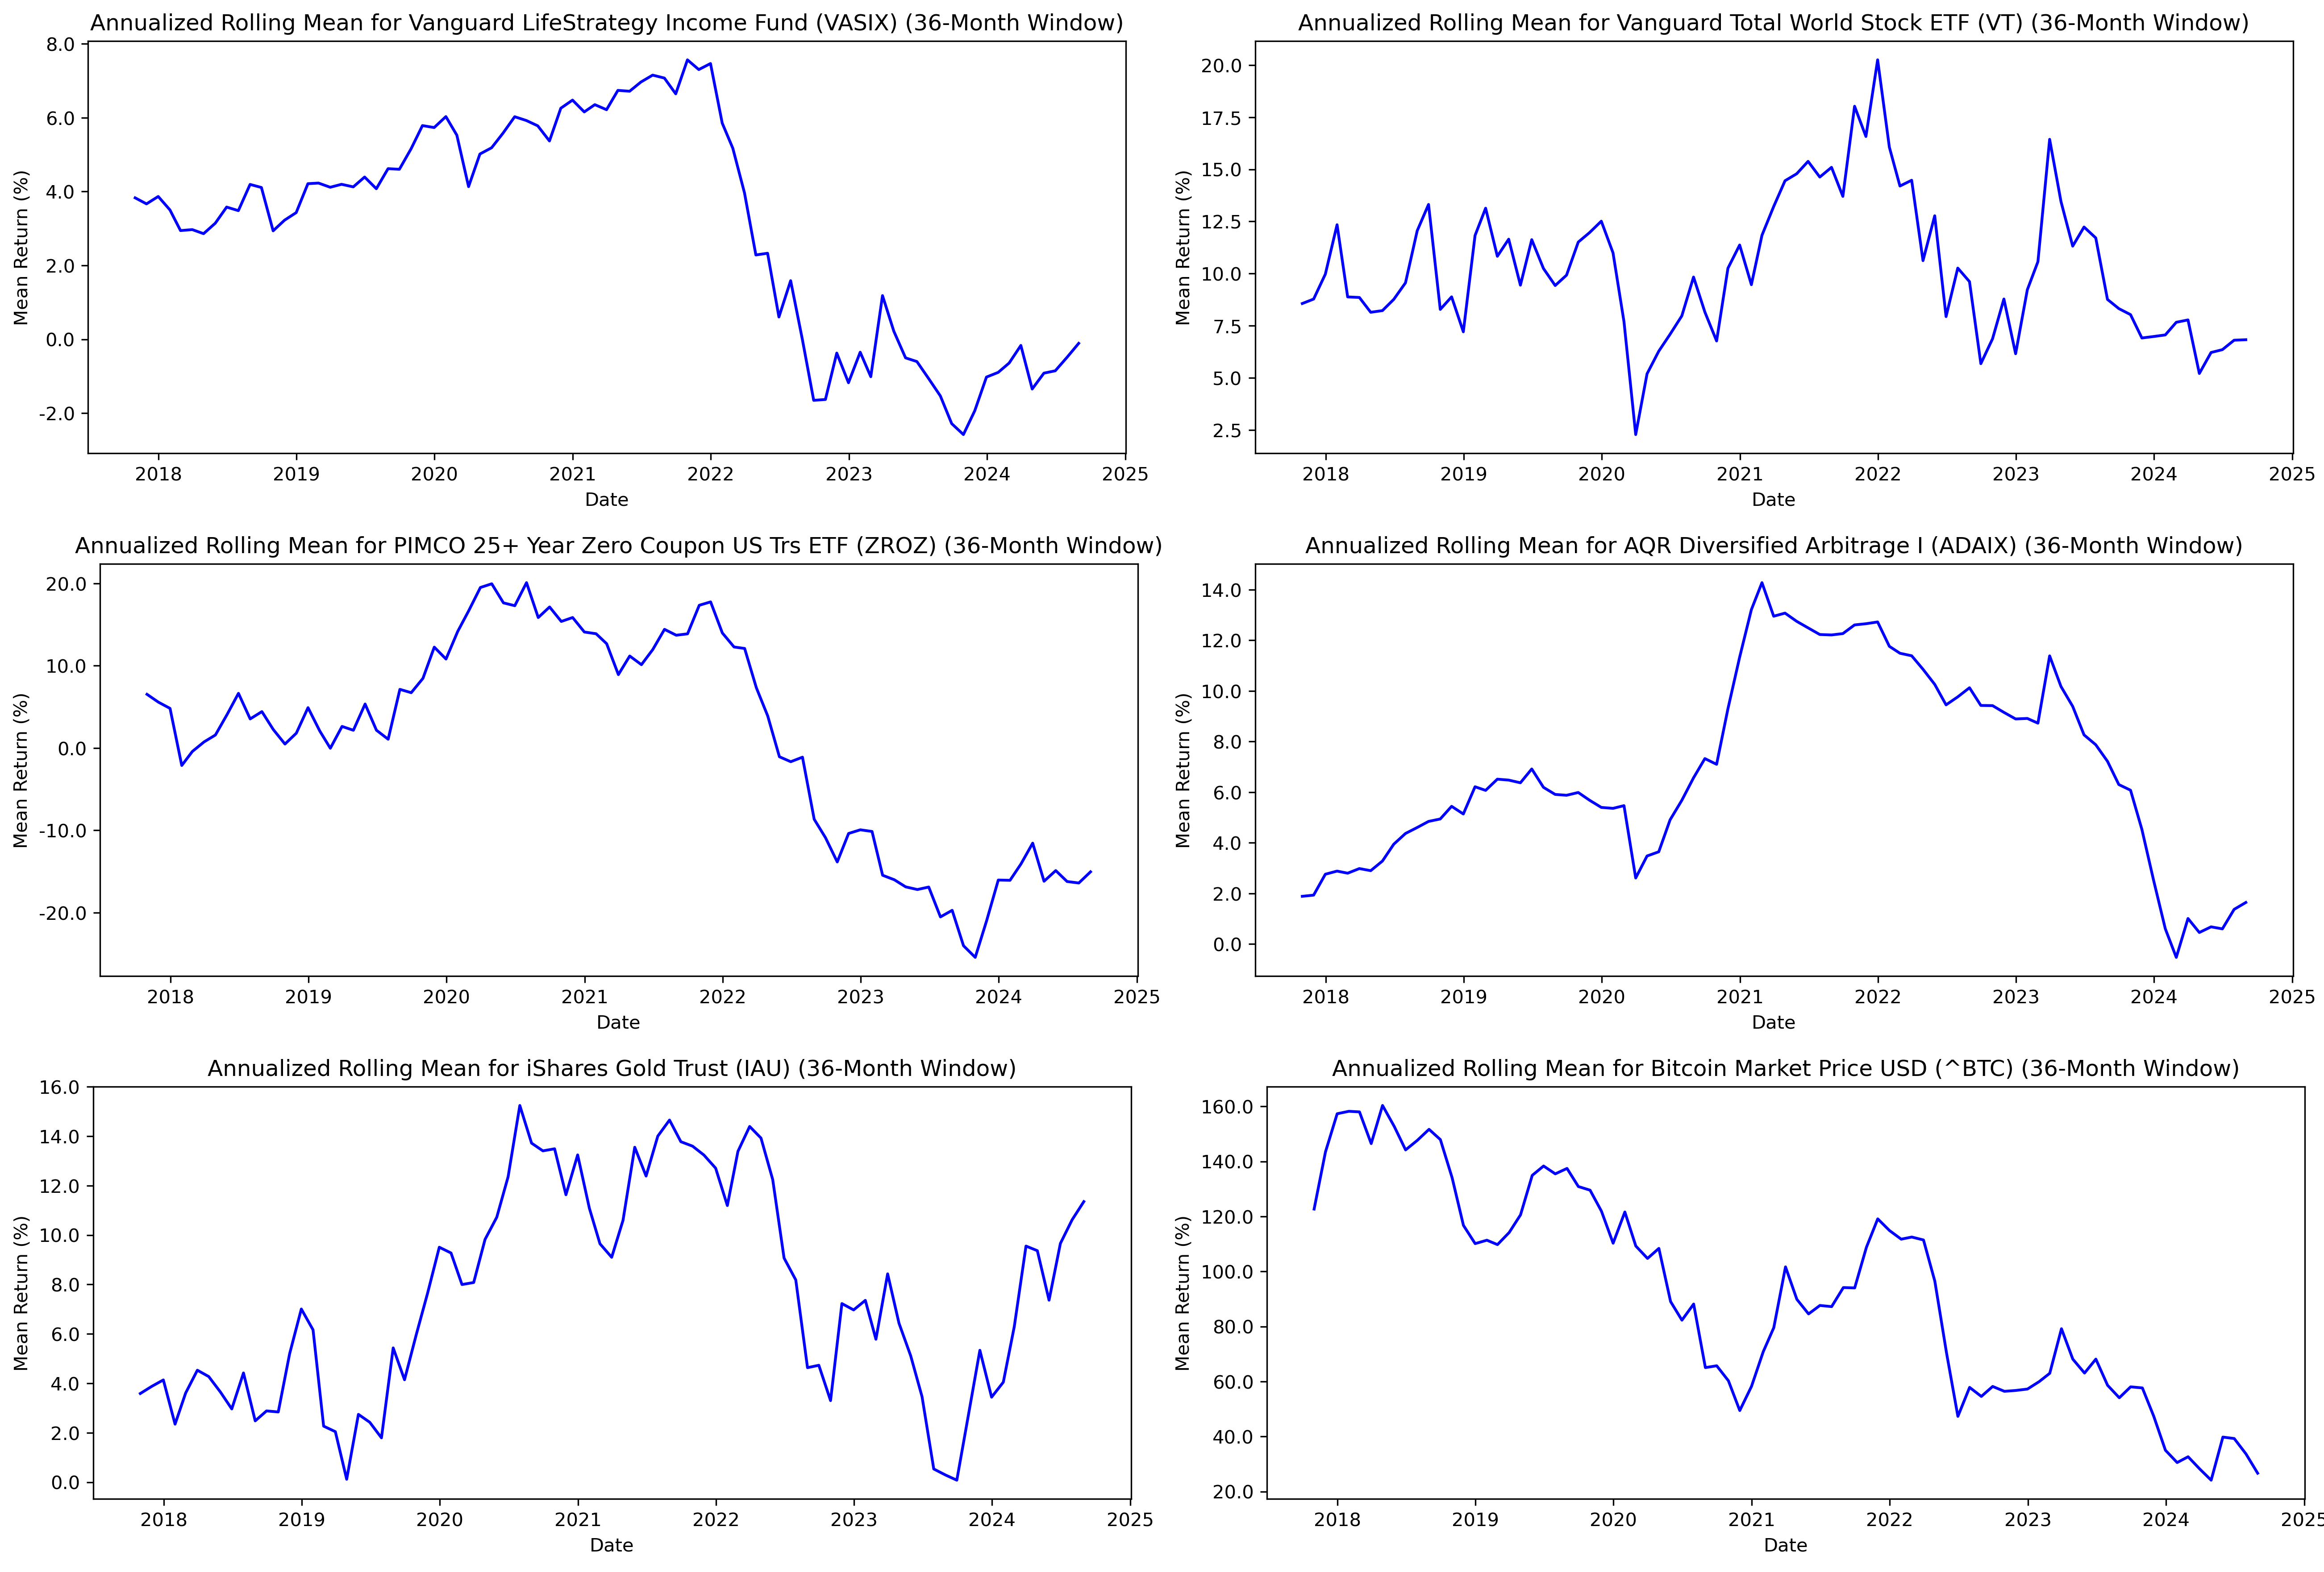

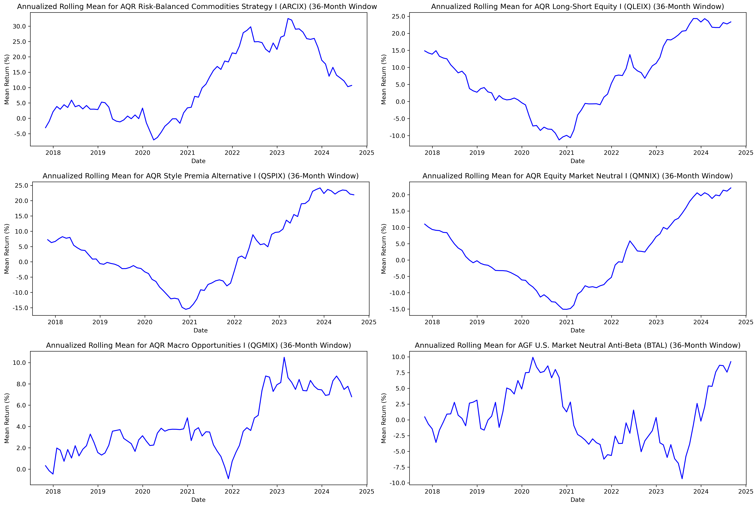

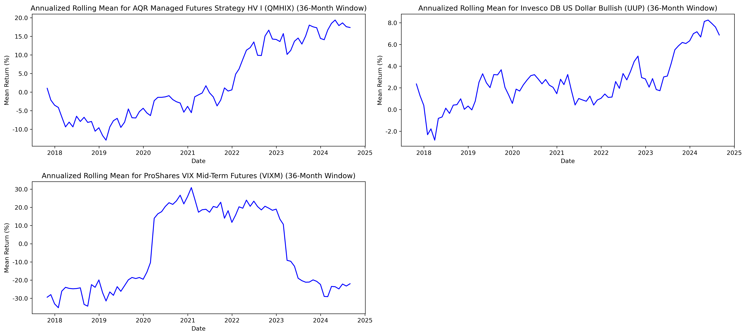

Here are bullet point observations based on the rolling 36-month means, standard deviations, and risk-adjusted returns for all assets:

Annualized Rolling Mean Returns:

Vanguard LifeStrategy Income Fund (VASIX):

* The rolling mean returns have gradually declined since 2021, indicating consistent underperformance in the current interest rate environment. This suggests that VASIX may not be as effective in capturing recent market opportunities, reflecting its conservative nature.

Vanguard Total World Stock ETF (VT):

* The rolling mean increased significantly in 2021, peaking around the middle of the year before declining in 2023. This implies that VT captured equity market gains during the post-pandemic recovery but suffered as markets faced increased volatility and tightening monetary conditions in 2022-2023.

PIMCO 25+ Year Zero Coupon US Treasury ETF (ZROZ):

* The rolling mean returns peaked in 2020-2021 but declined sharply afterwards, reflecting the impact of rising interest rates on long-duration bonds. This emphasizes ZROZ's interest rate sensitivity and explains its weak performance when interest rates increased.

AQR Diversified Arbitrage I (ADAIX):

* The rolling mean returns rose steadily into 2021, benefiting from a favorable arbitrage environment, but dropped in the last couple of years. This suggests that conditions became less conducive to arbitrage opportunities, likely driven by increased market volatility.

iShares Gold Trust (IAU):

* The rolling mean fluctuates widely, peaking during times of market uncertainty. Gold’s role as a safe haven becomes apparent, with improved performance during times of economic distress, making it a useful diversifier.

Bitcoin Market Price USD (^BTC):

* The rolling mean peaked in 2020-2021, benefiting from the bull market, but has since declined sharply as market sentiment shifted. This behavior highlights Bitcoin’s sensitivity to risk appetite, contributing positively during market rallies but suffering heavily during downturns.

AQR Risk-Balanced Commodities Strategy I (ARCIX):

* The rolling mean improved significantly in 2021, reflecting strong commodity markets, but has moderated since then. This illustrates its ability to perform well during inflationary periods but with vulnerability to commodity market cycles.

AQR Long-Short Equity I (QLEIX) and AQR Style Premia Alternative I (QSPIX):

* Both showed strong improvements in their rolling means post-2021, indicating that these strategies captured specific market opportunities or factor premiums effectively during the post-pandemic period.

AQR Equity Market Neutral I (QMNIX) and AQR Macro Opportunities I (QGMIX):

* Rolling mean returns have steadily increased, particularly in recent years, showing stable performance across different market regimes. This consistency indicates their diversification potential.

AGF U.S. Market Neutral Anti-Beta (BTAL):

* The rolling mean has risen steadily since 2021, suggesting that this anti-beta strategy has effectively captured periods of heightened volatility and downturns in equity markets.

AQR Managed Futures Strategy HV I (QMHIX):

* Rolling mean returns increased sharply from 2022 onward, benefiting from market dislocations and trends, which highlights the adaptability of managed futures in diverse market environments.

Invesco DB US Dollar Bullish (UUP):

* Rolling mean returns have improved notably since 2021, reflecting strength in the U.S. dollar as the Federal Reserve raised interest rates, which contributed positively during market uncertainty.

ProShares VIX Mid-Term Futures (VIXM):

* Rolling means show strong performance during spikes in market volatility, highlighting its role as a hedge during equity market turmoil but poor performance during periods of lower volatility.

Annualized Rolling Standard Deviations:

Vanguard LifeStrategy Income Fund (VASIX):

* The rolling standard deviation increased significantly starting in 2022, reflecting a shift in the risk profile due to changing interest rates and economic uncertainty.

Vanguard Total World Stock ETF (VT):

* The standard deviation remained fairly constant but increased during market turmoil. This aligns with VT’s exposure to global equity risk, leading to increased volatility during crises.

PIMCO 25+ Year Zero Coupon US Treasury ETF (ZROZ):

* Volatility increased significantly starting in 2021, indicating increased risk due to interest rate hikes. This is consistent with ZROZ's high sensitivity to rate changes.

AQR Diversified Arbitrage I (ADAIX):

* Rolling standard deviation remained stable for most of the period, but spiked around 2021. This shows that ADAIX faced episodic increases in volatility likely due to temporary market dislocations.

Bitcoin Market Price USD (^BTC):

* The rolling standard deviation decreased over time but remained extremely high, highlighting persistent volatility even during quieter periods. This is consistent with Bitcoin's highly speculative nature.

AQR Long-Short Equity I (QLEIX), AQR Style Premia Alternative I (QSPIX), and AQR Macro Opportunities I (QGMIX):

* Volatility rose gradually over time, reflecting their exposure to systematic risks. The steady increase highlights the evolving nature of factor-based strategies and macro opportunities in varying market conditions.

AGF U.S. Market Neutral Anti-Beta (BTAL) and AQR Managed Futures Strategy HV I (QMHIX):

* Both showed increasing volatility post-2021, demonstrating their responsiveness to increased market trends and disruptions, which allows them to benefit from dislocations but at the cost of greater risk.

Invesco DB US Dollar Bullish (UUP):

* The rolling standard deviation shows a gradual increase starting in 2022, reflecting increased volatility in the currency markets as central banks worldwide adjusted interest rates.

ProShares VIX Mid-Term Futures (VIXM):

* The standard deviation was notably high and spiked during episodes of increased volatility, reaffirming its nature as a hedge against market turmoil.

Annualized Rolling Risk-Adjusted Returns:

Vanguard LifeStrategy Income Fund (VASIX):

* The rolling risk-adjusted returns have trended downwards since 2021, indicating underperformance compared to the volatility experienced. This suggests that VASIX’s conservative allocation struggled to provide meaningful returns amid increased market turbulence.

Vanguard Total World Stock ETF (VT):

* Risk-adjusted returns have been highly volatile, peaking in 2021 but dropping thereafter, which reflects both high returns and high volatility associated with global equity markets.

PIMCO 25+ Year Zero Coupon US Treasury ETF (ZROZ):

* The risk-adjusted returns have declined sharply since 2021, reflecting the adverse impact of rising interest rates. ZROZ has underperformed due to its vulnerability to duration risk.

AQR Diversified Arbitrage I (ADAIX) and AQR Long-Short Equity I (QLEIX):

* Both strategies showed relatively stable and improving risk-adjusted returns, suggesting effective risk management and a favorable market environment for these strategies in recent years.

Bitcoin Market Price USD (^BTC):

* Rolling risk-adjusted returns have been consistently negative since mid-2021, indicating that the high volatility of Bitcoin has outweighed its return potential in recent market conditions.

AQR Style Premia Alternative I (QSPIX) and AQR Macro Opportunities I (QGMIX):

* Risk-adjusted returns have shown notable recovery since 2021, indicating these strategies benefited from factor premiums and macro opportunities as the market environment shifted.

AGF U.S. Market Neutral Anti-Beta (BTAL) and AQR Managed Futures Strategy HV I (QMHIX):

* Risk-adjusted returns improved significantly post-2021, reflecting the ability of these strategies to capitalize on increased market volatility. BTAL, in particular, performed well during equity downturns, suggesting a strong diversifying effect.

Invesco DB US Dollar Bullish (UUP):

* Risk-adjusted returns have increased steadily, peaking in 2023, reflecting strong dollar performance amid monetary tightening. This shows its effectiveness as a defensive asset during periods of market stress.

ProShares VIX Mid-Term Futures (VIXM):

* Risk-adjusted returns peaked during periods of high market volatility, consistent with its use as a hedge. However, performance suffered during calmer market conditions, indicating its limited role outside periods of stress.

Combined Commentary:

The rolling 36-month means, standard deviations, and risk-adjusted returns for all assets provide a dynamic perspective on their performance and risk profiles over time, highlighting how certain assets outperformed in times when others underperformed, contributing to their diversification potential.

* VASIX, as the benchmark, demonstrates stability but underperformance during periods of increased market turmoil, reflecting its conservative nature.
* VT, BTC, and ZROZ exhibited high return variability and risk, indicating they can provide high returns during favorable conditions but carry significant downside risk.
* Managed futures (QMHIX), market neutral (QMNIX), and anti-beta (BTAL) strategies showed resilience during periods of increased volatility, offering effective diversification by performing well when other assets faced challenges.
* Gold (IAU) and commodities (ARCIX) showed strong performance during periods of market uncertainty, reinforcing their role as effective diversifiers.
* Currency (UUP) and VIX-related (VIXM) assets also provided strong performance during times of uncertainty, highlighting their role in managing portfolio risk and capitalizing on monetary tightening and volatility shocks.

Overall, the rolling metrics underscore the benefit of combining different assets with diverse characteristics to achieve a more balanced portfolio. By leveraging assets that perform well in different market environments, it is possible to outperform a conservative benchmark like VASIX, while better managing overall risk and improving the consistency of returns over time.

**Asset Risk-Return Characteristics**

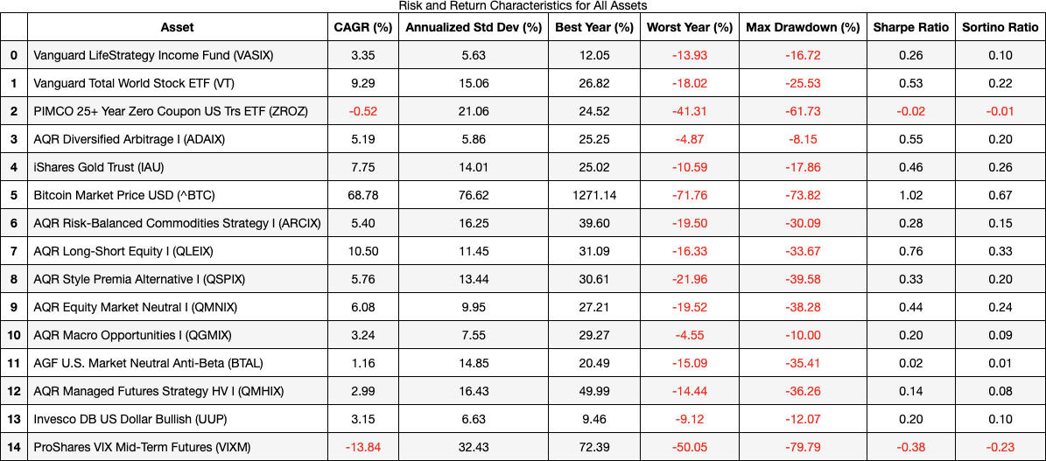

Here are bullet point observations based on the summary table of risk and return characteristics for all assets:

Risk and Return Characteristics:

CAGR (Compound Annual Growth Rate):

* Bitcoin (BTC) stands out with a CAGR of 68.78%, showcasing the high potential returns but with substantial risk. This aligns with earlier findings of high volatility and extreme tail risks.
* Vanguard Total World Stock ETF (VT) has a respectable CAGR of 9.29%, reflecting its exposure to global equity markets. It demonstrates the trade-off of relatively high returns but with significant risk.
* The Vanguard LifeStrategy Income Fund (VASIX), with a CAGR of 3.35%, falls short in comparison to other assets. However, its low risk makes it a consistent benchmark, as observed throughout the analysis.
* PIMCO 25+ Year Zero Coupon US Treasury ETF (ZROZ) exhibits negative CAGR (-0.52%), reinforcing the impact of rising interest rates on long-duration Treasuries as noted in earlier rolling mean return analyses.

Annualized Standard Deviation:

* The standard deviations range from 5.63% for VASIX to 76.62% for Bitcoin, highlighting the wide disparity in risk levels among the assets. Assets like ZROZ and commodities (ARCIX) show considerable volatility, consistent with their sensitivity to macroeconomic conditions.
* AQR Long-Short Equity I (QLEIX) has a moderate standard deviation (11.45%), suggesting controlled risk relative to its returns, consistent with earlier stability observed in risk-adjusted returns.

Best and Worst Year:

* The best year for Bitcoin (BTC) showed a staggering 1271.14% return, while its worst year also reflects severe losses (-71.76%), emphasizing the high-risk, high-reward nature of cryptocurrency investing.
* The worst year for ZROZ (-41.31%) highlights its susceptibility to interest rate risk, while VIXM and other highly volatile assets experienced substantial losses during their worst years.
* VASIX, QMNIX, and UUP had relatively limited downside in their worst years, reflecting their stable and defensive characteristics.

Max Drawdown:

* PIMCO 25+ Year Zero Coupon US Treasury ETF (ZROZ) and ProShares VIX Mid-Term Futures (VIXM) experienced substantial drawdowns, exceeding -60%, indicating that these assets are highly vulnerable during market downturns. This aligns with earlier analyses that showed their risk profiles and extreme tail events.
* VASIX had a max drawdown of -16.72%, much lower than most of the other assets, emphasizing its role as a conservative income-generating benchmark.
* Gold (IAU) and QLEIX had relatively smaller drawdowns, indicating a more controlled downside risk compared to high-risk assets like BTC or VIXM.

Sharpe Ratio:

* Bitcoin (BTC) leads with a Sharpe ratio of 1.02, indicating a favorable risk-adjusted return over the period analyzed. However, this high Sharpe ratio needs to be considered in the context of high volatility and potential for extreme losses.
* QLEIX shows a Sharpe ratio of 0.76, reflecting an attractive risk-adjusted return profile for a long-short equity strategy. It suggests that QLEIX is well-managed and can provide value as part of a diversified strategy.
* The Sharpe ratio for VASIX is lower (0.26), consistent with its conservative nature and lower expected returns, which makes it less favorable when compared to other riskier assets.

Sortino Ratio:

* The Sortino ratio paints a similar picture as the Sharpe ratio, with Bitcoin (BTC) having a higher value (0.67), indicating a favorable upside potential relative to downside risk. However, its extreme volatility still makes it a challenging asset for many investors.
* QLEIX and IAU also have moderately high Sortino ratios, indicating effective downside risk control and aligning with their relatively lower drawdowns compared to other riskier assets like VIXM or ZROZ.
* VASIX and other conservative assets have lower Sortino ratios, reflecting their limited upside, but their downside risk remains manageable.

Combined Commentary:

The table of risk and return characteristics provides a quantitative summary that reinforces and contextualizes earlier visual analyses and bootstrapped metrics, highlighting the trade-offs between risk and return across different asset classes. The insights gleaned from this table speak directly to the diversification potential of various assets when constructing an optimal portfolio:

* VASIX, as the benchmark, provides low but stable returns with limited volatility and drawdown, making it a solid base for income-seeking investors. However, its low Sharpe and Sortino ratios reflect its limited return potential, which has been an ongoing concern given recent economic conditions.
* Bitcoin (BTC) offers exceptionally high returns but with extremely high volatility and potential for drawdown, highlighting its role as a high-risk, high-reward asset. Its favorable Sharpe ratio suggests that, during favorable market periods, BTC can add significant value to a diversified portfolio, but it must be used cautiously to avoid outsized risk.
* Global equities (VT) and gold (IAU) demonstrate balanced profiles with good return potential relative to their volatility. Gold, in particular, has shown value as a diversifier during times of market stress, which aligns with its historical role as a hedge.
* PIMCO 25+ Year Zero Coupon US Treasury ETF (ZROZ), with negative returns, significant volatility, and a high drawdown, highlights the downside of long-duration bond exposure in a rising interest rate environment, as discussed in earlier sections. This underscores the importance of reducing such exposure in future strategies.
* AQR Long-Short Equity (QLEIX), Equity Market Neutral (QMNIX), and Managed Futures (QMHIX) have shown attractive risk-adjusted returns, moderate volatility, and reasonable drawdowns, emphasizing their potential to add stability and diversification in a portfolio, particularly during times when broader markets have struggled.
* VIXM and currency (UUP) products have demonstrated usefulness during periods of heightened volatility and monetary tightening, respectively. While VIXM is highly volatile with a large drawdown, its positive role as a hedge against market turbulence cannot be ignored.

Diversification Insights:

In the context of the broader report, this analysis highlights the power of diversification across assets with differing risk-return characteristics:

* High-volatility, high-reward assets such as Bitcoin and global equities can be used to enhance portfolio returns during favorable market conditions, but must be tempered with more stable assets to avoid outsized risk.
* Low-volatility, stable assets such as VASIX, market-neutral funds, and UUP help to anchor the portfolio and provide stability, especially during market downturns. Their role as risk dampeners is crucial when seeking to outperform in a risk-managed way.
* Alternatives such as managed futures, commodities, and gold serve as effective diversifiers, particularly during market turmoil or inflationary environments, as they typically move differently compared to traditional equities and bonds.

By incorporating these various assets into a diversified portfolio, investors can aim to outperform the benchmark VASIX while maintaining a more balanced risk profile. The insights presented here underscore the value of a dynamic, diversified approach that is responsive to changing economic conditions, leveraging the unique characteristics of each asset to provide better risk-adjusted returns and more consistent performance over time.

**Model Selection**

* Ray Dalio All Weather motivation
* Discuss *Risk Parity, Maximum, Diversification, and Minimum Variance: An Analytic Perspective*

**Model Analysis**

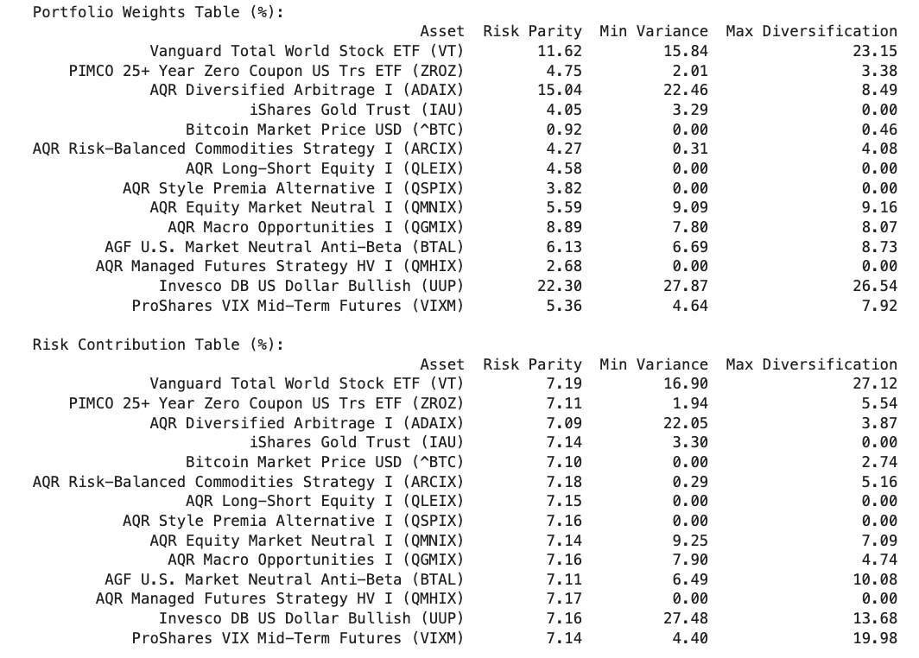

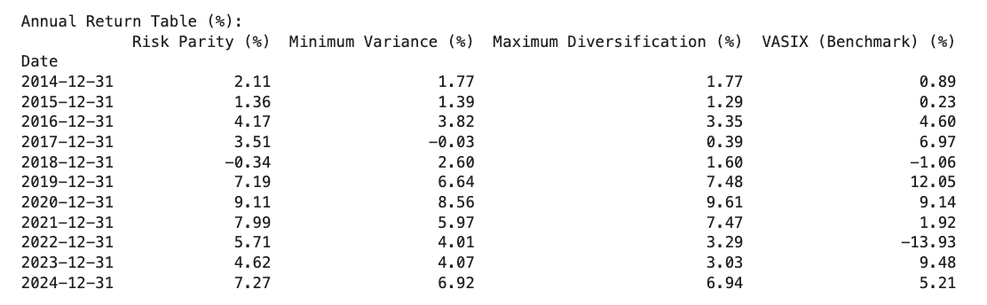

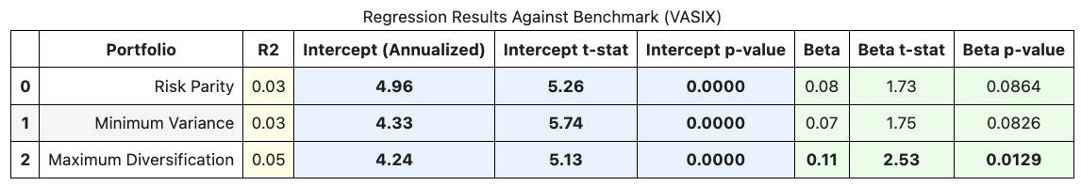

Key Insights and Performance Interpretation

1. Portfolio Weights and Concentration:
   * The portfolio weight allocation between Risk Parity, Minimum Variance, and Maximum Diversification has different approaches to risk management:
     + Risk Parity focuses on balancing risk contributions across assets. The weights are distributed in a way that each asset's risk contribution is equal. This approach generally results in a more evenly distributed portfolio compared to minimum variance or maximum diversification, leading to relatively lower concentration.
     + Minimum Variance focuses on minimizing the portfolio’s overall risk, irrespective of asset returns. This leads to excluding a large number of assets from the portfolio, concentrating on those with the lowest risk. The technical report emphasizes that this portfolio lies on the efficient frontier’s leftmost tip and uses only a small proportion of the investable set due to constraints such as a long-only approach and shrinking beta thresholds (which excludes assets with high systematic risk)​(Risk_Parity,_Maximum_Di…).
     + Maximum Diversification aims to maximize the diversification ratio, selecting assets that contribute most to diversification benefits. Weights are determined by a ratio of asset volatilities to overall portfolio risk, which results in an allocation that favors assets contributing the least to overall risk. It tends to employ more assets than the minimum-variance approach, providing a compromise between diversification and risk control.
2. Risk Contribution:
   * The Risk Contribution Table shows how the portfolios achieve diversification:
     + In the risk parity approach, the contributions from each asset are more uniform, reflecting its aim to balance risk evenly.
     + Minimum variance portfolios tend to be heavily skewed towards low-risk assets, resulting in uneven risk contributions, which also explains the higher portfolio concentration.
     + Maximum diversification aims to reduce correlations among the assets, resulting in weights that are proportional to the asset's ability to diversify risk, rather than its individual volatility.
3. Performance Metrics:
   * In terms of performance, Risk Parity shows the highest CAGR (5.38%) and lowest maximum drawdown (-2.87%) compared to other strategies, consistent with its objective of balancing risk and potentially avoiding concentration in highly volatile assets.
   * Minimum Variance has the lowest standard deviation (2.35%) and a relatively low CAGR (4.66%), indicating that while it is successful at minimizing risk, it may also sacrifice potential returns.
   * Maximum Diversification sits between the two, providing a reasonable balance between CAGR and volatility (4.71% and 2.61%, respectively). It is designed to provide better returns than a purely minimum-variance approach while reducing risk through diversification benefits.
4. Regression Results:
   * The Regression Analysis Table reveals that the intercepts for all three portfolios are statistically significant, indicating potential alpha relative to the benchmark (VASIX).
   * Risk Parity has a beta of 0.08, suggesting it has lower sensitivity to market movements compared to other portfolios, making it an appealing option for risk-averse investors.
   * The Maximum Diversification portfolio exhibits a higher beta (0.11) than the other two, aligning with its approach to seek diversification while tolerating higher market sensitivity.

Limitations and Considerations

1. Data Limitations and Specific Timeframes:
   * The results are subject to the characteristics of the underlying asset set and the particular timeframe used in the analysis. Different market environments might yield different results, especially for Minimum Variance portfolios that rely on historical correlations and volatilities that can shift dramatically.
2. Model Assumptions:
   * The portfolios are optimized under certain assumptions, such as constant asset covariance and using historical returns for risk estimation. These assumptions may not hold in periods of extreme market stress, leading to deviations from the expected portfolio performance.
   * For example, the Risk Parity approach, while robust during normal market conditions, could be vulnerable to extreme changes in correlation structures across assets, which might cause the intended balance of risk contributions to become less effective.
3. Historical Beta and Shrinkage:
   * The paper highlights the use of a shrinkage technique for beta estimates to avoid extreme weights that could be impractical. This also emphasizes the challenges in relying purely on historical risk models, which could overestimate or underestimate risk in a shifting market regime​(Risk_Parity,_Maximum_Di…).
4. Negative Betas and Portfolio Construction:
   * Negative betas play an interesting role in the risk parity and minimum variance portfolios. Assets with negative betas (often viewed as hedging assets) can receive significant weights to offset other risk exposures. However, the technical report warns that portfolios may become unstable with an increase in assets possessing extreme negative betas​(Risk_Parity,_Maximum_Di…).

Summary

* The optimized portfolios, constructed under Risk Parity, Maximum Diversification, and Minimum Variance frameworks, each have unique strengths and limitations that make them suitable for different investor preferences.
* The Risk Parity portfolio, with more even risk distribution and lower volatility, may appeal to those seeking steady, lower-risk returns. Minimum Variance focuses heavily on minimizing risk but may lack adequate exposure to potential high-return assets. Maximum Diversification offers a middle ground by attempting to maximize returns relative to risk through improved diversification.

The analysis reveals the importance of understanding each portfolio's objective, risk structure, and assumptions. It also emphasizes that real-world portfolio performance may deviate from backtested results, especially during periods of market turmoil or when correlations between asset classes increase significantly, challenging traditional diversification strategies.

**Conclusion and Recommendations**

The findings from this comprehensive analysis suggest that the diversification opportunities within the examined asset set offer meaningful potential for optimizing portfolios in a way that aligns with clients' evolving needs. Specifically, the Risk Parity approach stands out due to its balanced risk contributions and inclusiveness, avoiding over-concentration or exclusion of specific assets. Based on the analysis presented and incorporating several ideas for further enhancement, the following recommendations and next steps are proposed:

1. Extend Data Collection: Expanding the dataset to include additional periods and a broader range of macroeconomic data would be beneficial. More historical data can improve the robustness of the model, particularly in capturing different market cycles. This additional data can also be leveraged for more nuanced simulations and scenario analysis.

2. Factor Analysis and Regression with Macroeconomic Data: Performing detailed regressions on assets against macroeconomic and financial market factors could help isolate specific drivers of performance and provide a better understanding of exposures. This information would also be useful in constructing synthetic returns when historical data is unavailable, potentially filling gaps in the analysis.

3. Incorporate Machine Learning Techniques: Machine learning techniques could be utilized to group assets into clusters that represent unique risk-return characteristics. Such clustering could simplify portfolio construction by providing a set of representative assets that capture distinct risk factors, reducing redundancy in exposure.

4. Broaden Goodness-of-Fit Testing: The analysis could benefit from the inclusion of additional goodness-of-fit tests like Anderson-Darling, Shapiro-Wilk, D'Agostino’s K-squared, and Jarque-Bera to further evaluate distribution characteristics, particularly with respect to skewness and kurtosis. This would provide more granular insights into the behavior of return distributions, supporting the use of non-parametric bootstraps or parametric bootstraps that align with the observed characteristics.

5. Evaluate the Use of Parametric Bootstraps: Using parametric bootstraps, informed by goodness-of-fit findings, could provide additional insights into asset performance under different scenarios. This approach could be particularly useful in stress testing and evaluating the robustness of portfolio allocations.

6. Simulation Enhancements: To improve the accuracy of Monte Carlo simulations, it is recommended to use goodness-of-fit tests (such as AIC, BIC, and K-S) to determine the most appropriate distribution (Normal, T, or Cauchy) for each asset's returns. For capturing more realistic tail risks and non-linear relationships, simulations based on non-normal distributions should also be explored.

7. Focus on Correlation Preservation in Simulations: Ensuring that simulations accurately preserve **correlation structures** between assets is critical. Given the importance of diversification, it is crucial that simulated data reflect realistic relationships among assets, especially during extreme market conditions, where correlations often converge and reduce the benefits of diversification.

8. Consider Non-Parametric and Non-Normal Monte Carlo Simulations: Given the non-normal behavior observed in the return distributions of certain assets, Monte Carlo simulations based on non-normal distributions are recommended. These simulations would likely provide a more accurate depiction of potential future outcomes, particularly for assets that exhibit significant skewness or heavy tails.

9. Adopt the Risk Parity Portfolio: Given its balanced risk approach, Risk Parity is recommended as a practical and effective allocation strategy. By not over-relying on any single asset while also not excluding potentially valuable ones, Risk Parity ensures that the portfolio is well-positioned to withstand a range of economic conditions. It demonstrated lower maximum drawdowns compared to other approaches, providing stability during adverse market periods.

10. Develop Synthetic Return Estimation Techniques: Beyond traditional regression, developing models for synthetic return estimation based on macroeconomic and market factors would be highly valuable. This approach could provide a deeper understanding of the potential behaviors of assets, particularly those with limited historical data.

Summary

The analysis highlights the effectiveness of employing diversified portfolio construction strategies, particularly focusing on **Risk Parity**, which balances risk without over-concentration. Moving forward, enhancing data collection, incorporating detailed regression analysis, broadening goodness-of-fit assessments, and exploring machine learning techniques will provide a deeper understanding of asset behavior and portfolio dynamics. These steps will refine and strengthen the analysis, ultimately offering more robust portfolio recommendations that align with the clients' risk and return objectives.